Baker’s Unsweetened Chocolate

Ingredients: Chocolate

**Made on equipment that processes milk.

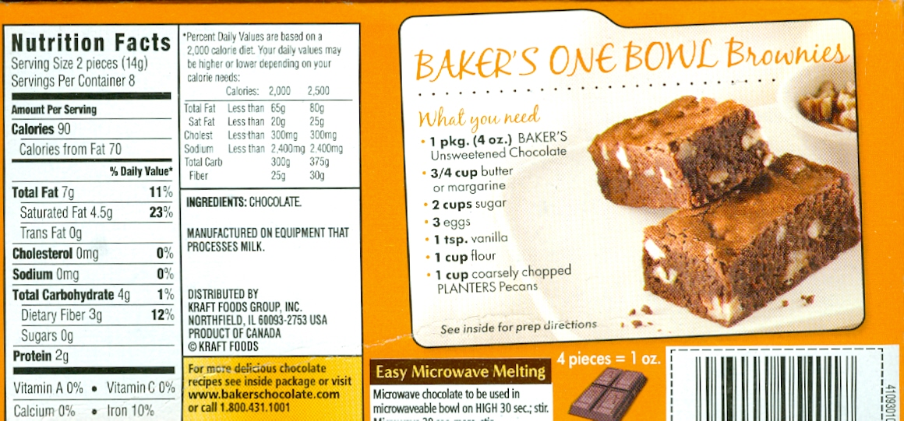
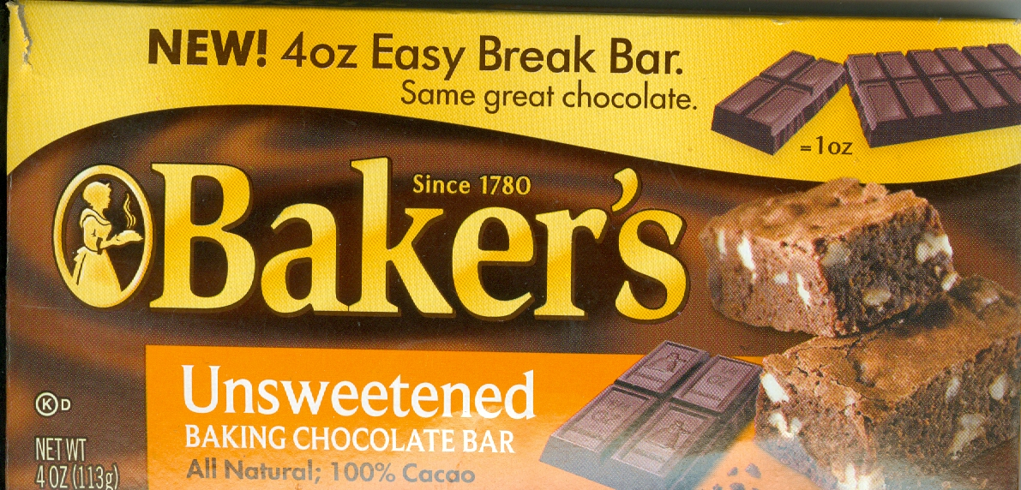

America’s Choice Chocolate Chips

Ingredients: Sugar, Chocolate Liquor, Cocoa Butter, Butterfat (Milk), Soy Lecithin, Vanilla

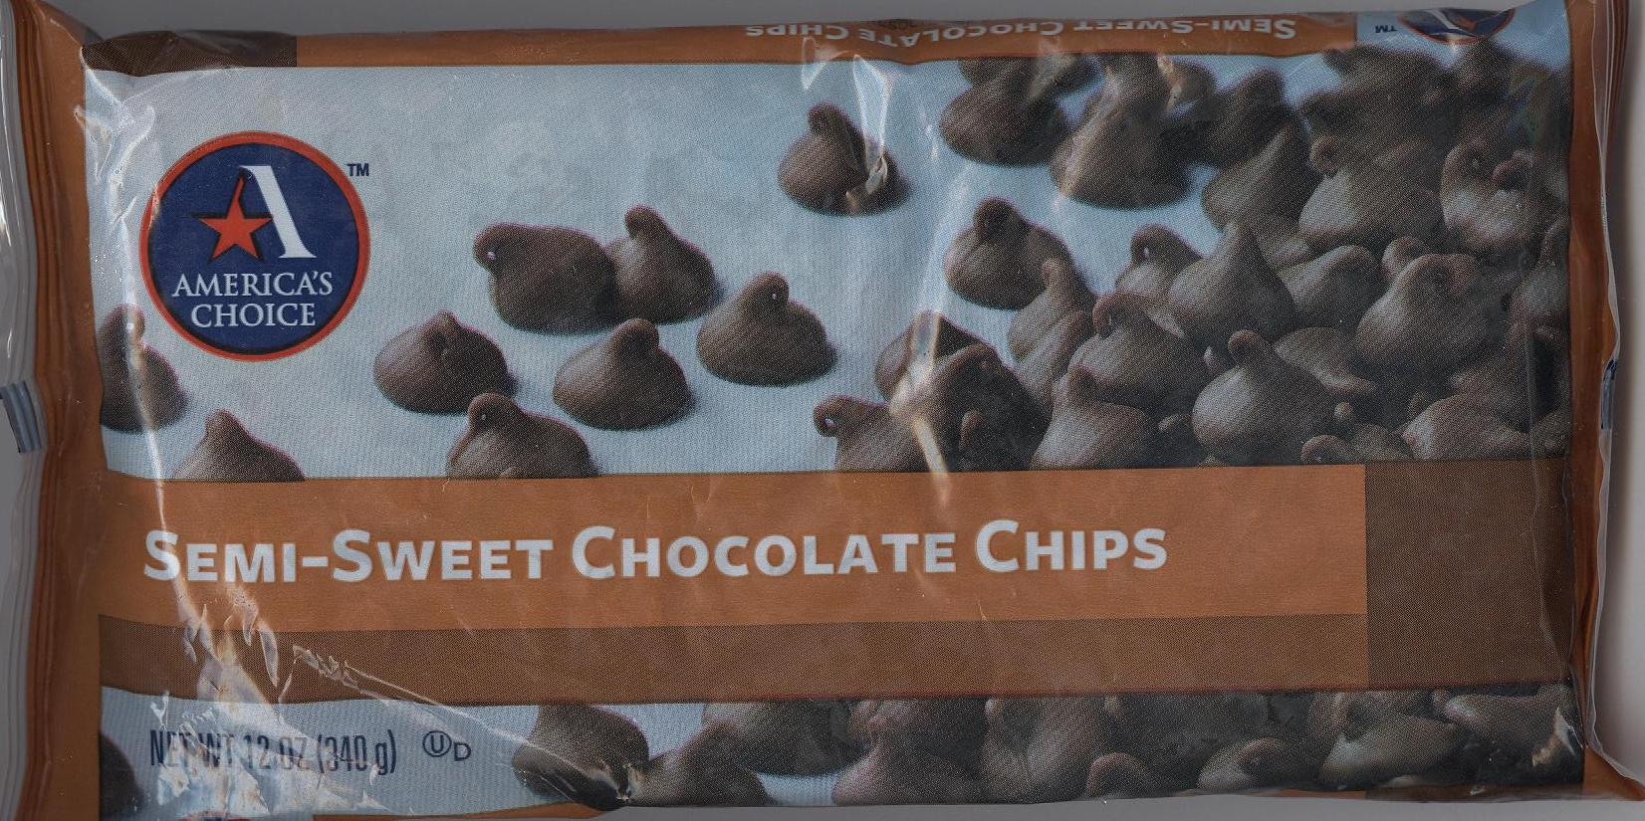

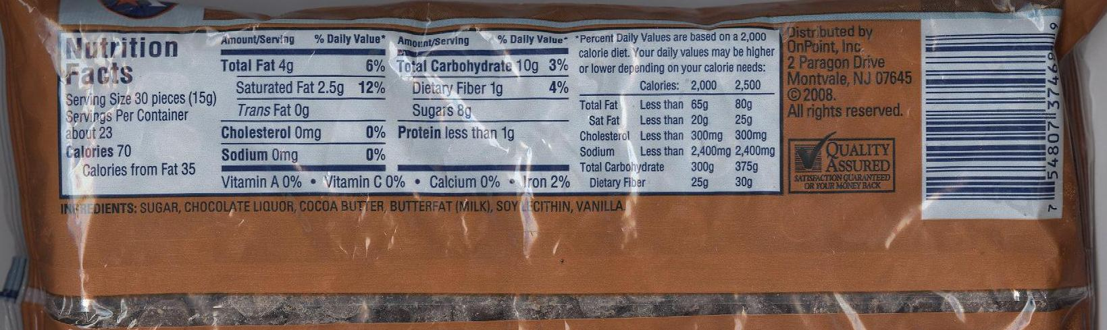

Domino Dark Brown Sugar

Ingredients: Brown Sugar

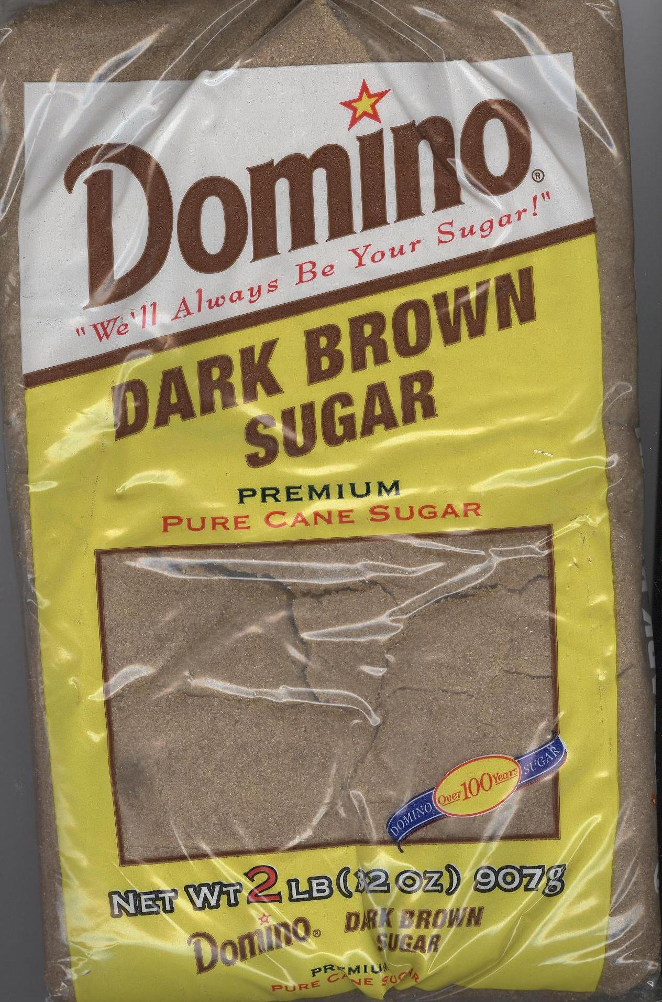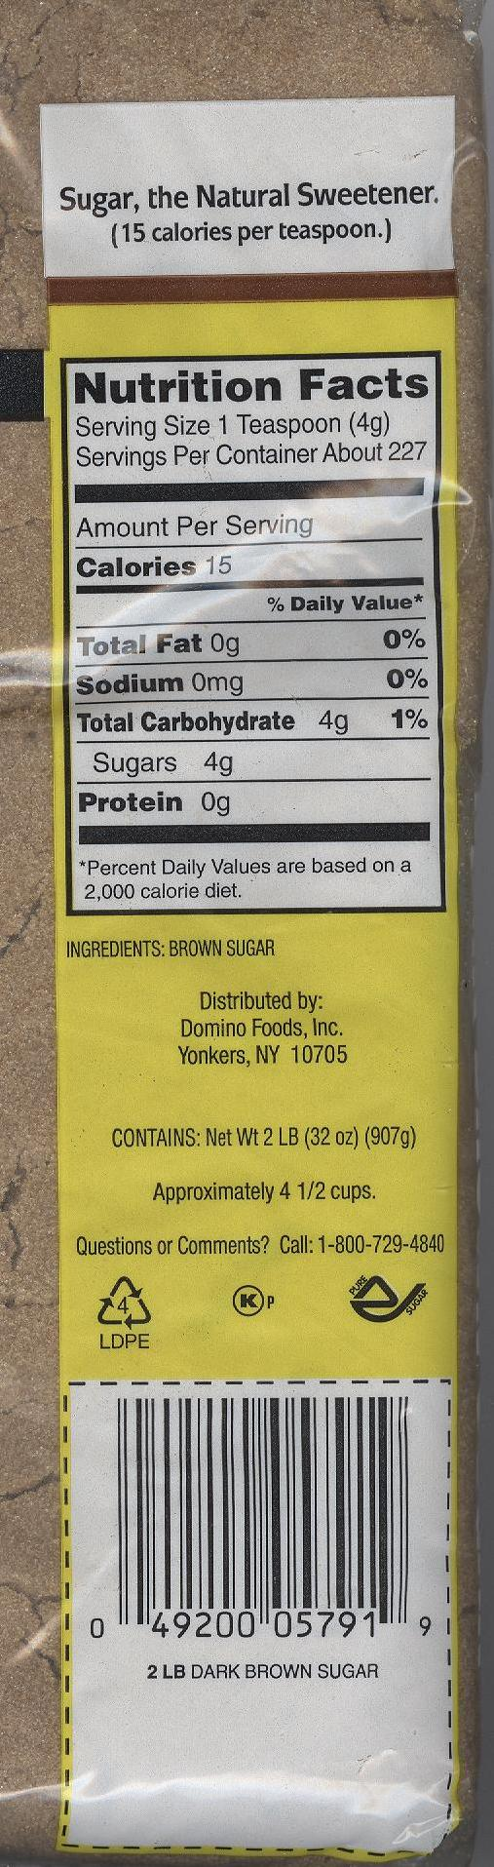
America’s Choice Imitation Vanilla Extract

Ingredients: Water, Alcohol (1%), Caramel Color, Natural and Artificial Flavors, Ethyl Vanillin, Citric Acid

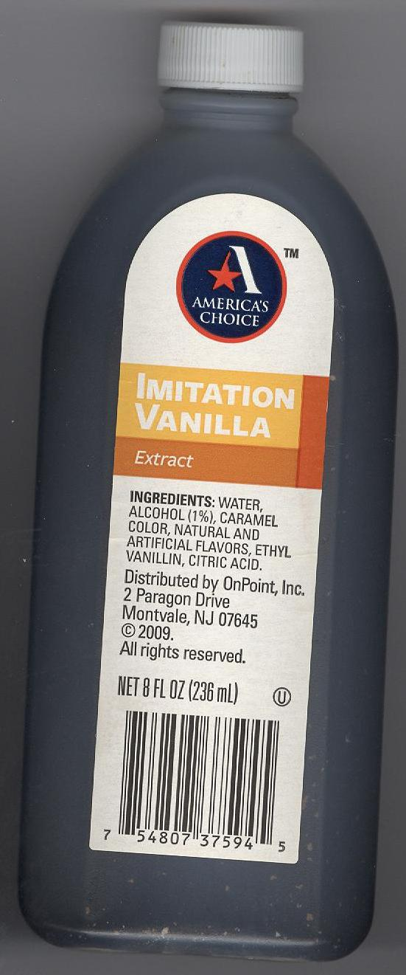

Master Choice Vanilla Extract

Ingredients: Water, Alcohol (1%), Caramel Color, Natural and Artificial Flavors, Ethyl Vanillin, and Citric Acid

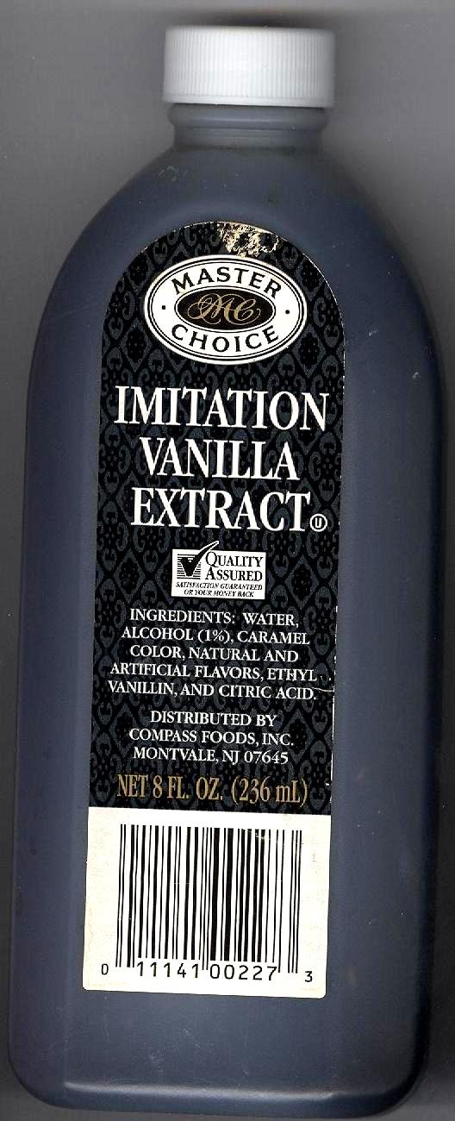

America’s Choice Canola Oil
Cooking Spray

Ingredients: Canola Oil, Soy Lecithin, Water, Propellant
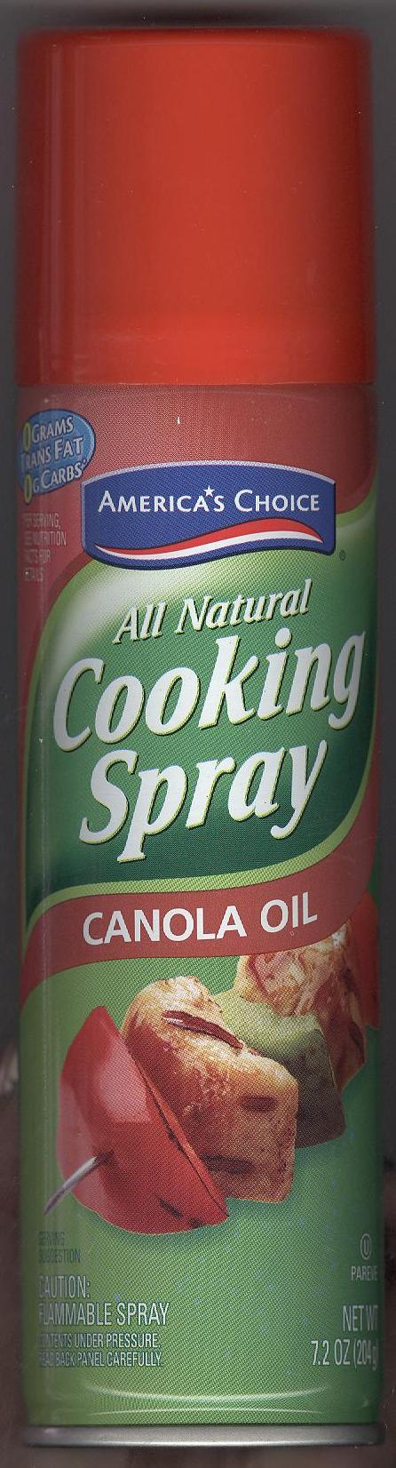
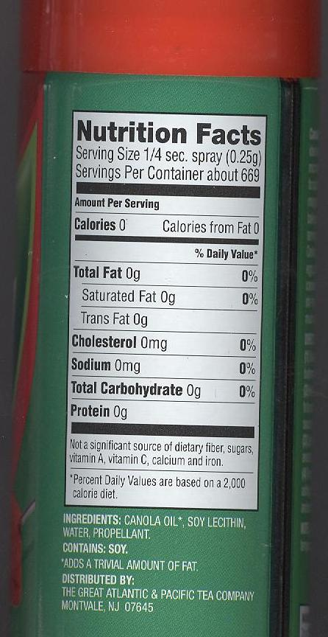
*Contains Soy

America’s Choice Vegetable Oil
Cooking Spray

Ingredients: Soybean Oil, Soy Lecithin, Water, Propellant

*Contains Soy

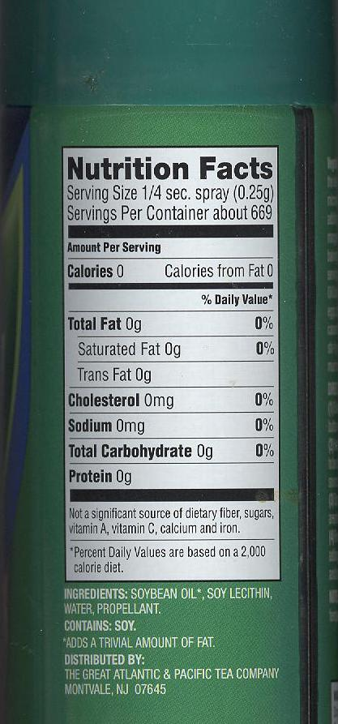

Baker’s Joy Cooking Spray

Ingredients: Soybean Oil, Propellant (Isobutane and/or Propane), Hydroxylated Soy Lecithin, Soy Lecithin, Enriched Flour (Wheat Flour, Niacin, Iron, Thiamin Mononitrate, Riboflavin, Folic Acid), Silicon Dioxide, TBHQ (To protect freshness)

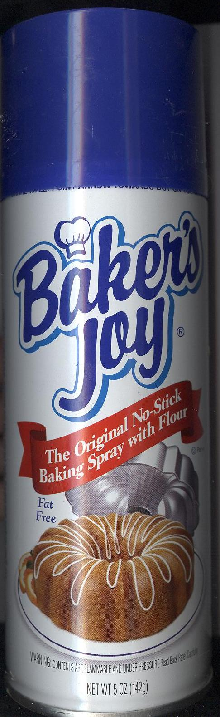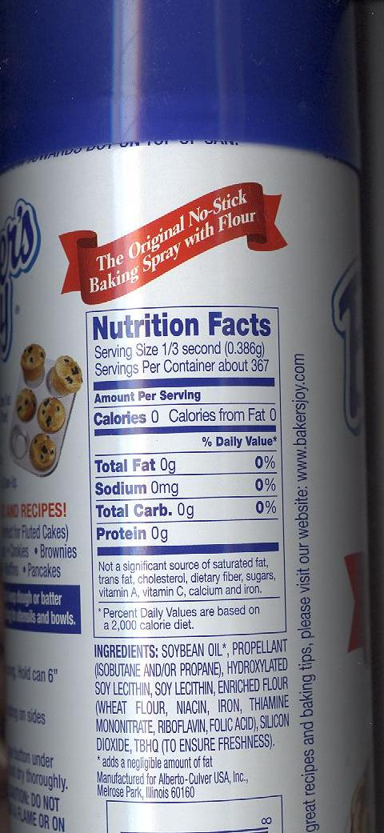

Sargento Whole Milk Mozzarella Cheese

Ingredients: Pasteurized Milk, Vinegar, Salt, Enzymes

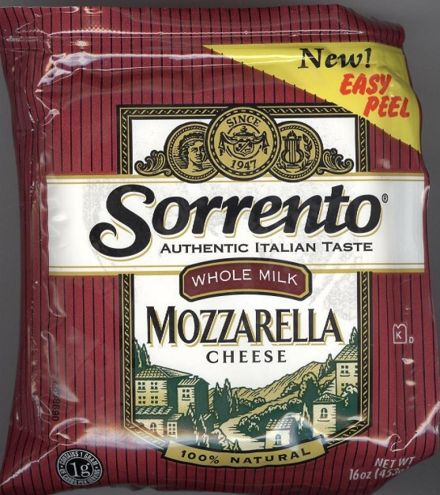

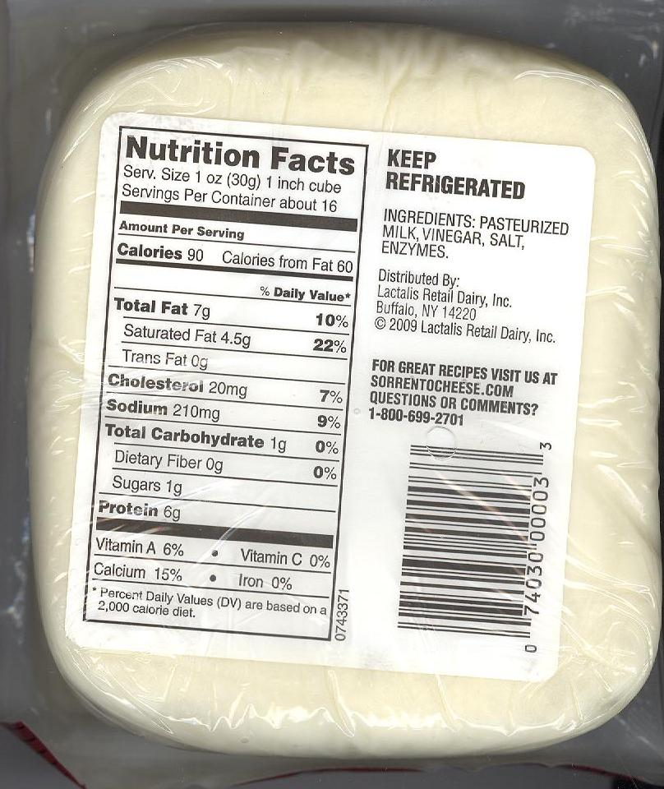

America’s Choice Parmesan Cheese

Ingredients: Parmesan Cheese (Pasteurized Cultured Milk, Salt, Enzymes, Powdered Cellulose, and Corn Starch added to prevent caking), Potassium Sorbate (Added to Protect Flavor)

*Contains Milk

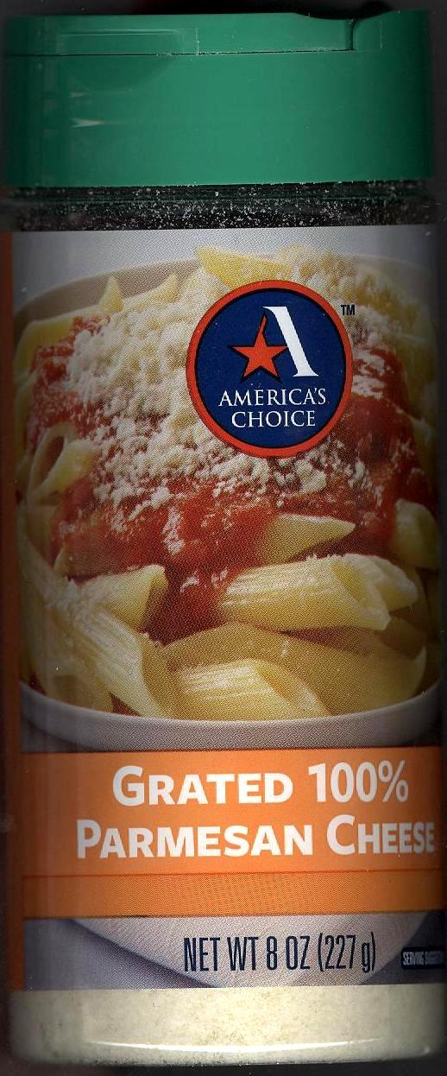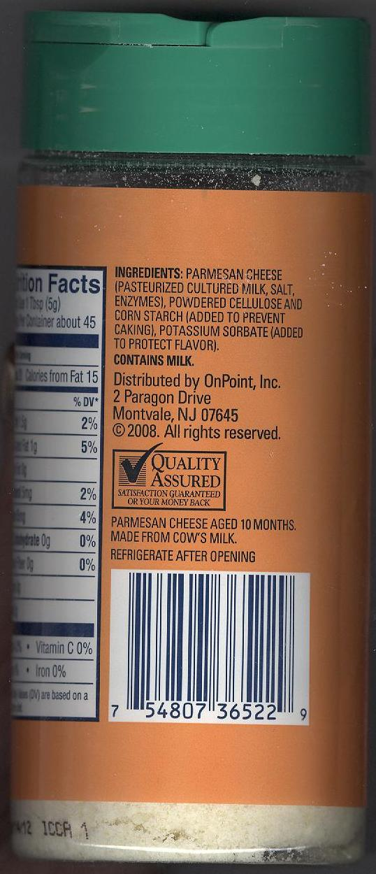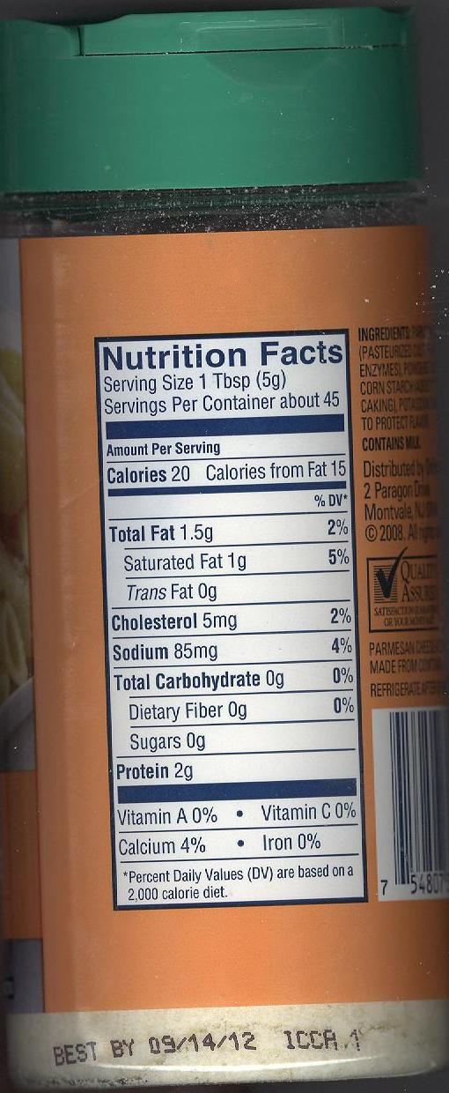

America’s Choice Unsalted Butter

Ingredients: Cream, Natural Flavorings

*Contains Milk

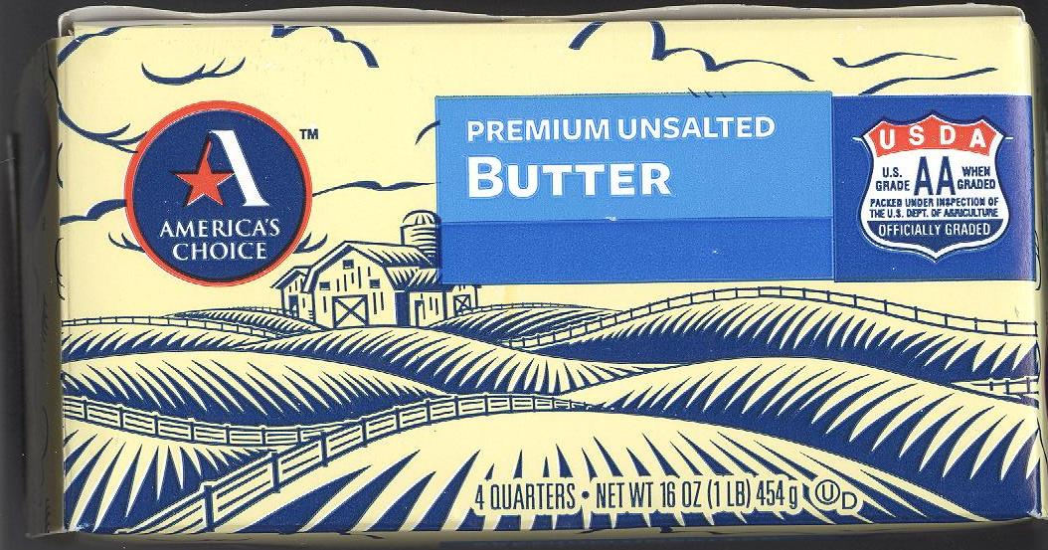

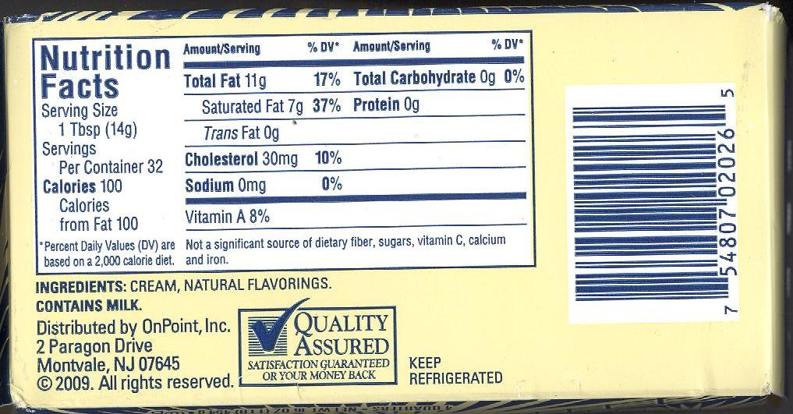

Alba Instant Powdered Milk

Ingredients: Non-fat Dry Milk. Vitamin A Palmitate, Vitamin D3

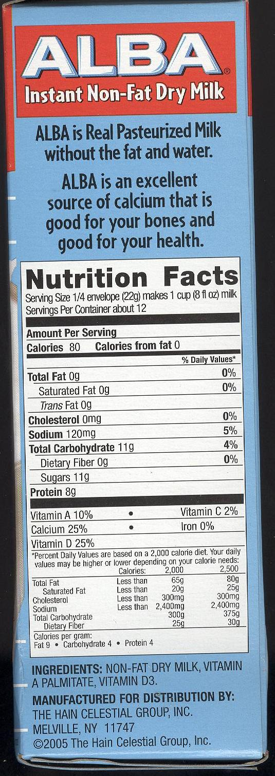

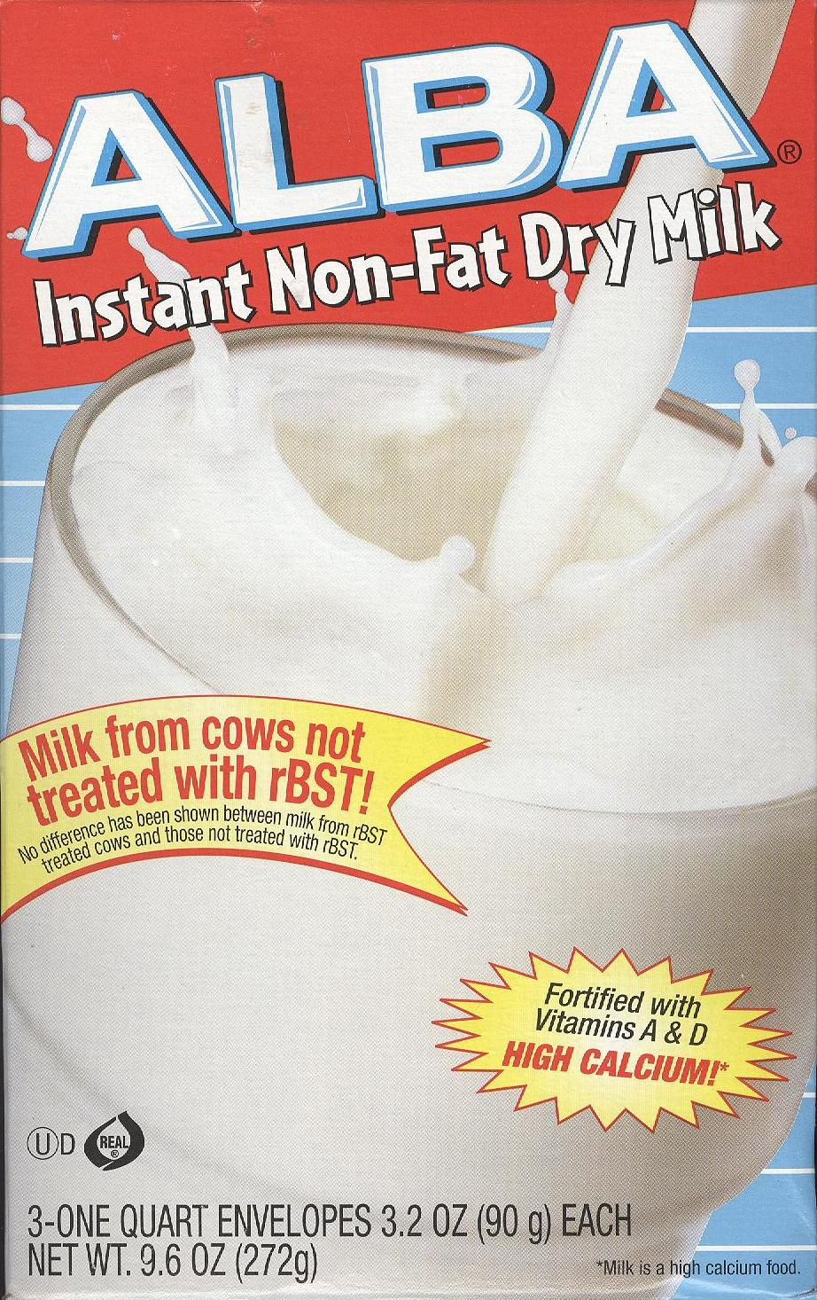

Original Bisquick

Ingredients: Enriched Flour Bleached (wheat flour, niacin, iron, thiamin mononitrate, riboflavin, folic acid), Partially Hydrogenated Soybean and/or cottonseed oil, Leavening (baking soda, sodium aluminum phosphate, monocalcium phosphate), Dextrose, Salt

*Check individual boxes as some package labels may include lactose and buttermilk

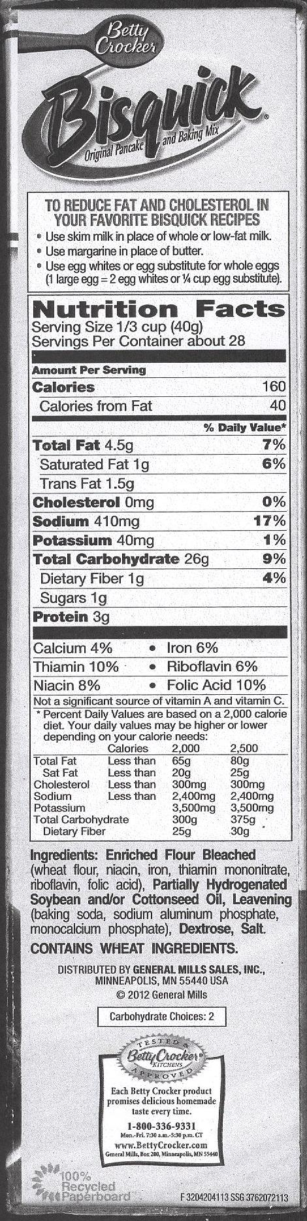

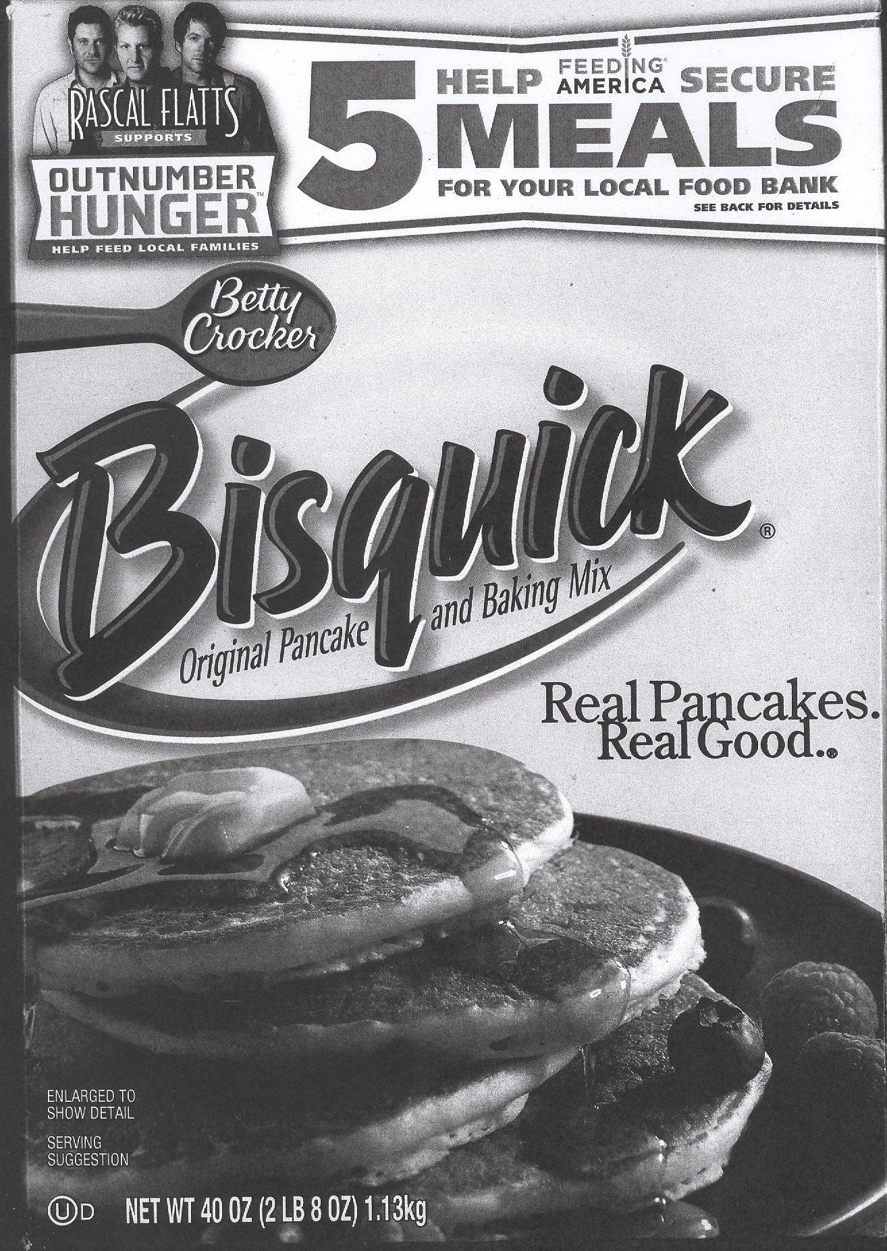

America’s Choice All-Purpose Flour

Ingredients: Enriched bleached flour (niacin, reduced iron, thiamin mononitrate, riboflavin, folic acid), malted barley flour.

** Contains Wheat

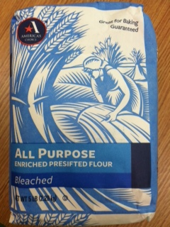

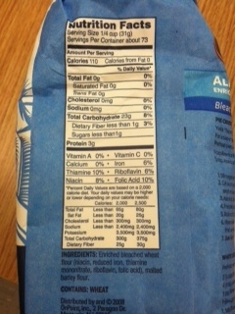

America’s Choice Cheddar Cheese

Ingredients: Pasteurized Milk, Cheese Culture, Salt, Enzymes and Annatto (Vegetable Color)

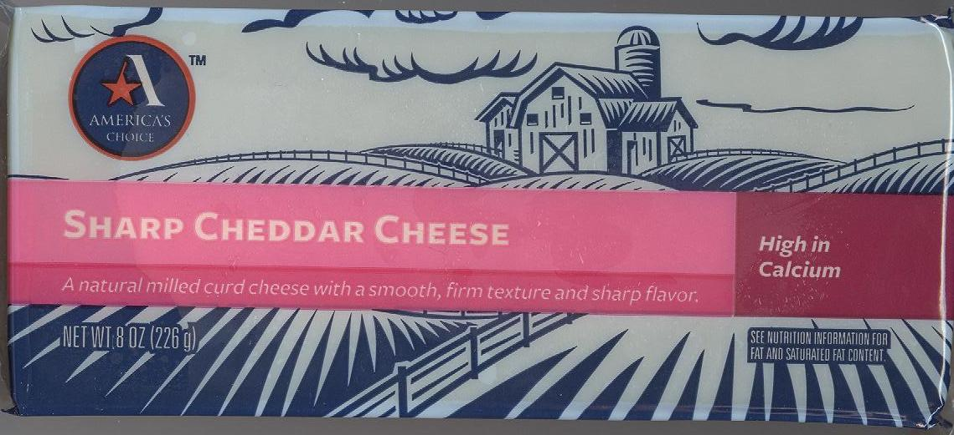

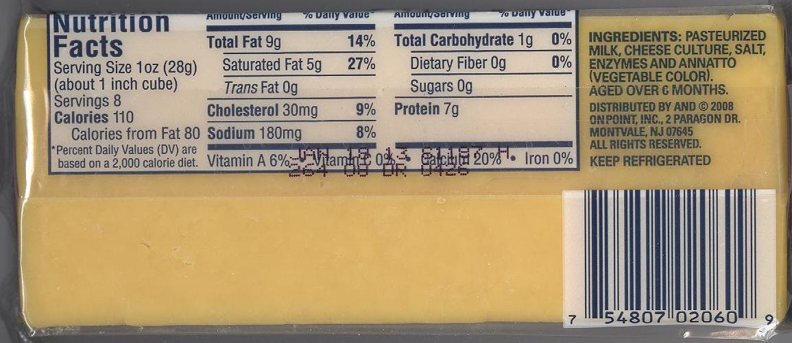

Ragu Old World Style
Traditional Marinara Sauce

Ingredients: Tomato Puree (Water, Tomato Paste), Soybean Oil, Salt, Sugar, Dehydrated Onions, Extra Virgin Olive Oil, Spices, Romano Cheese (Part Skim Milk, Cheese Cultures, Salt, Enzymes), Natural Flavor

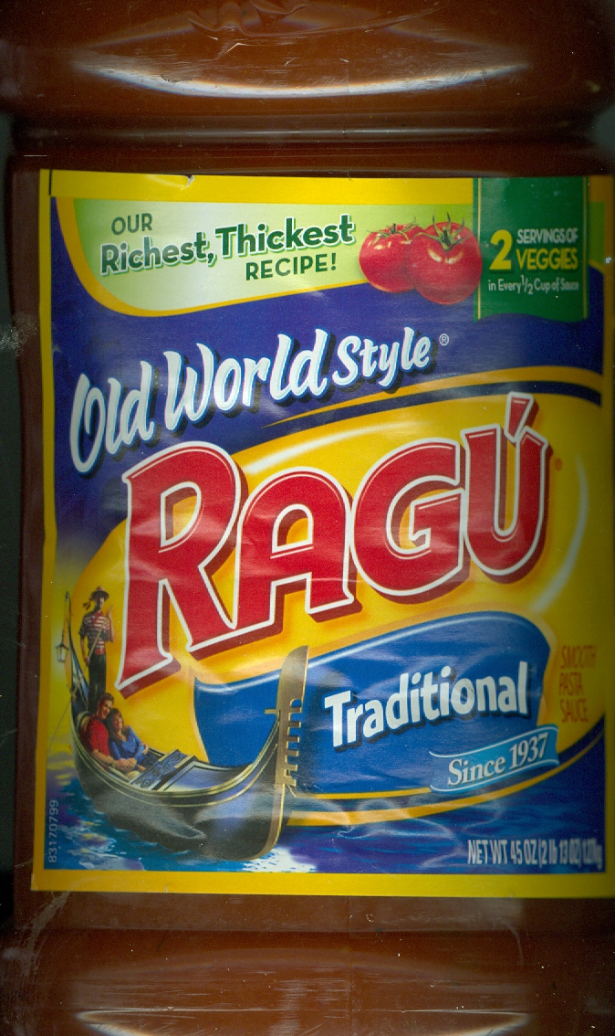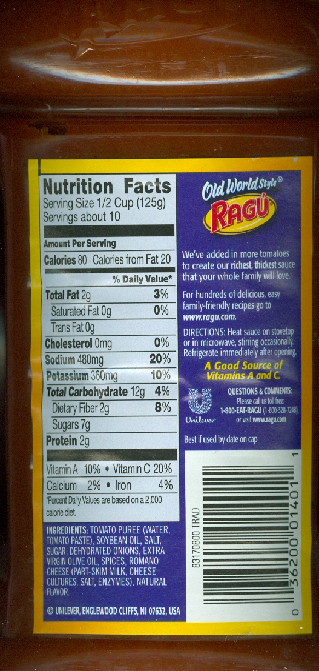

America’s Choice
Marinara Pasta Sauce

Ingredients: Tomato Puree (Water, Tomato Paste), Sugar, Soybean Oil, Salt, Dehydrated Onions, Extra Virgin Olive Oil, Garlic, Spices, Lemon Juice

America’s Choice
Whole Wheate Penne Rigate

Ingredients: Durum Whole Wheat Flour

**Contains Wheat ingredients.**
**Processed in a Facility that uses Egg**

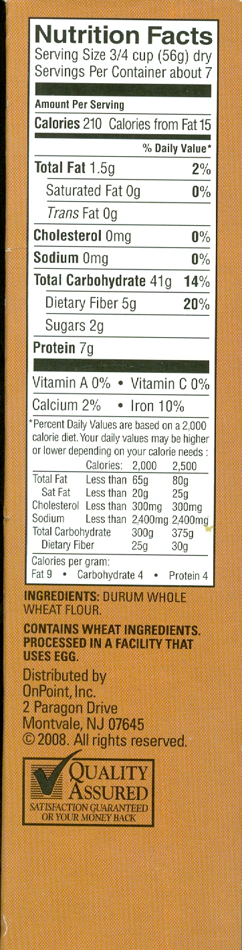

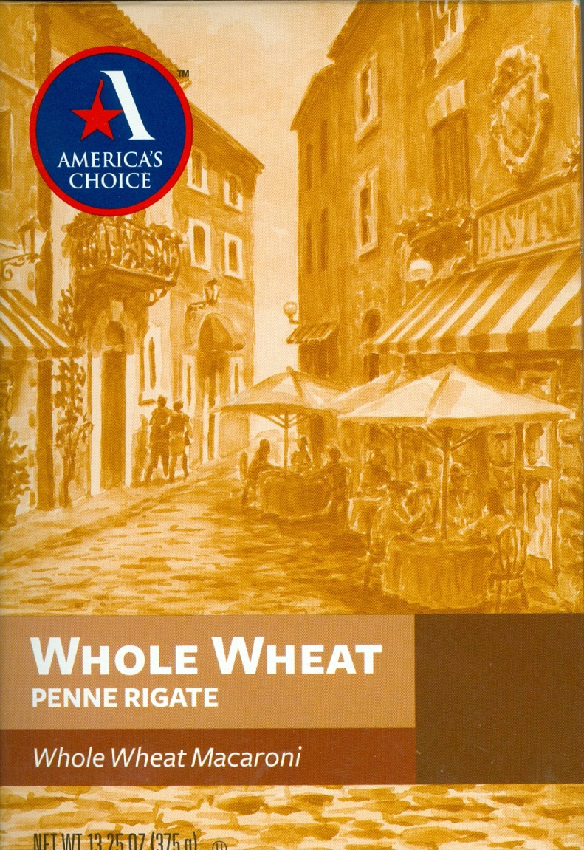

Argo Aluminum-Free Baking Powder

Ingredients: Sodium Acid Pyrophosphate, Sodium Bicarbonate, Corn Starch, Monocalcium Phosphate

**A Gluten Free Product**

