America’s Choice Cheddar Cheese

Ingredients: Pasteurized Milk, Cheese Culture, Salt, Enzymes and Annatto (Vegetable Color)

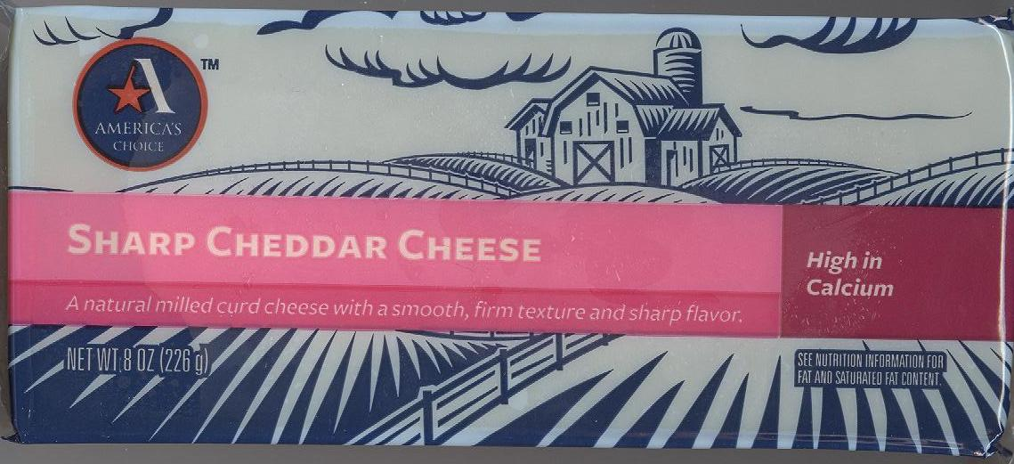

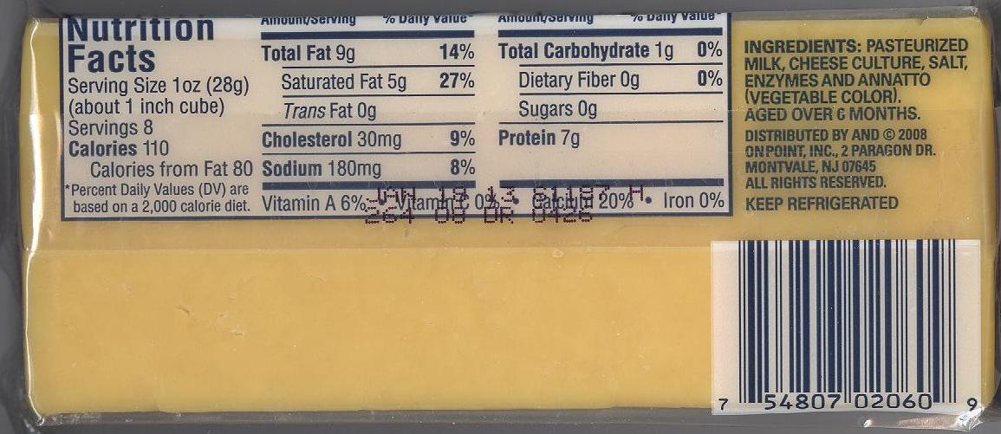

Alba Instant Powdered Milk

Ingredients: Non-fat Dry Milk. Vitamin A Palmitate, Vitamin D3

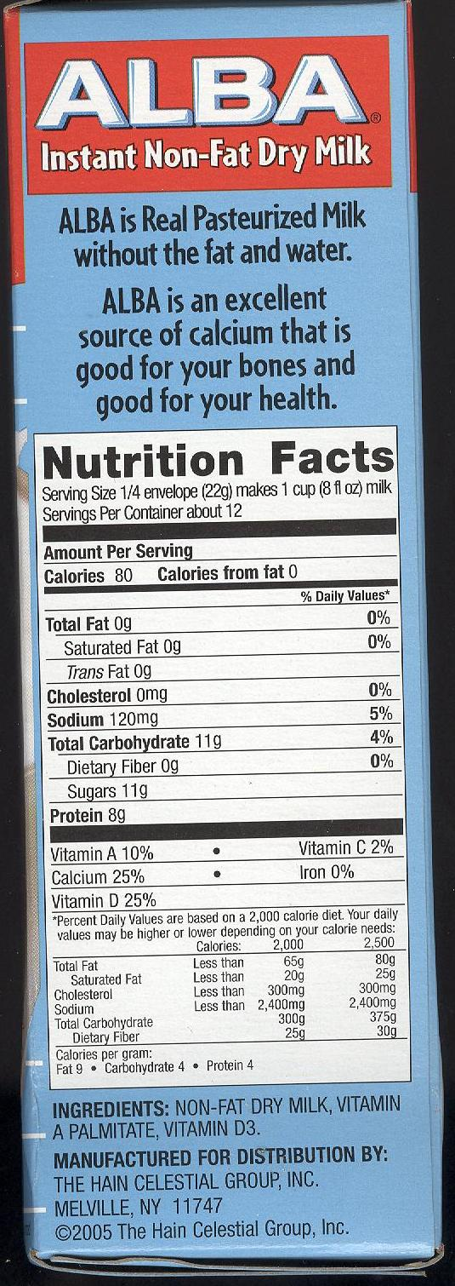

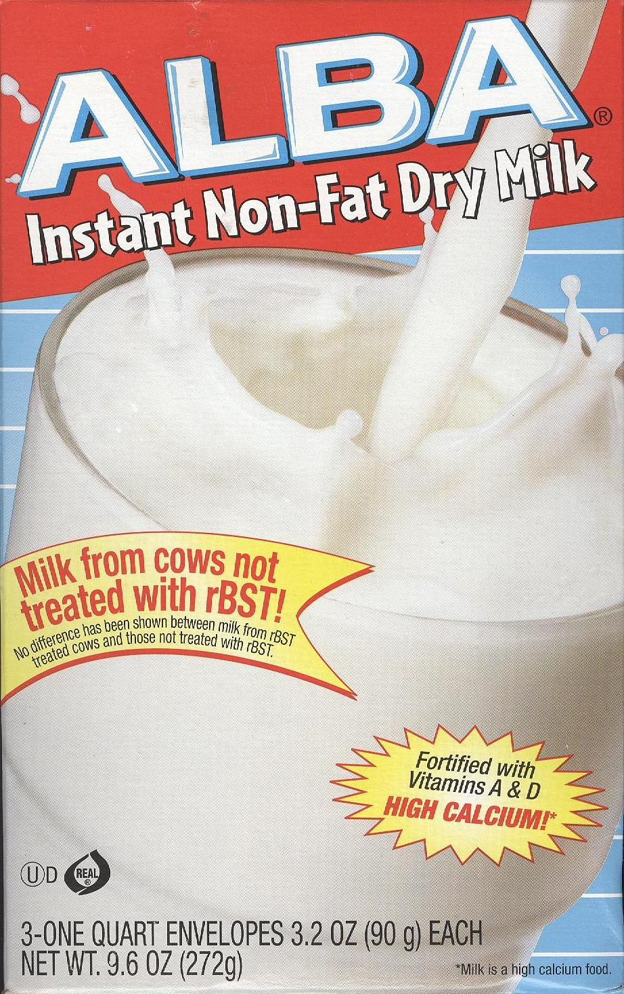

Original Bisquick

Ingredients: Enriched Flour Bleached (wheat flour, niacin, iron, thiamin mononitrate, riboflavin, folic acid), Partially Hydrogenated Soybean and/or cottonseed oil, Leavening (baking soda, sodium aluminum phosphate, monocalcium phosphate), Dextrose, Salt

*Check individual boxes as some package labels may include lactose and buttermilk

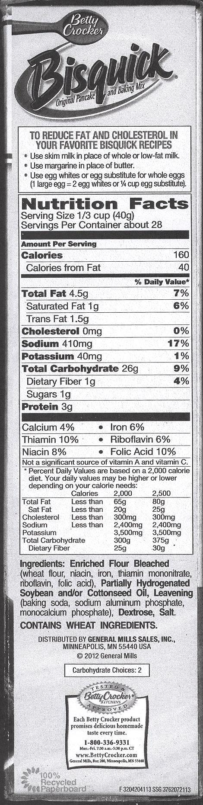

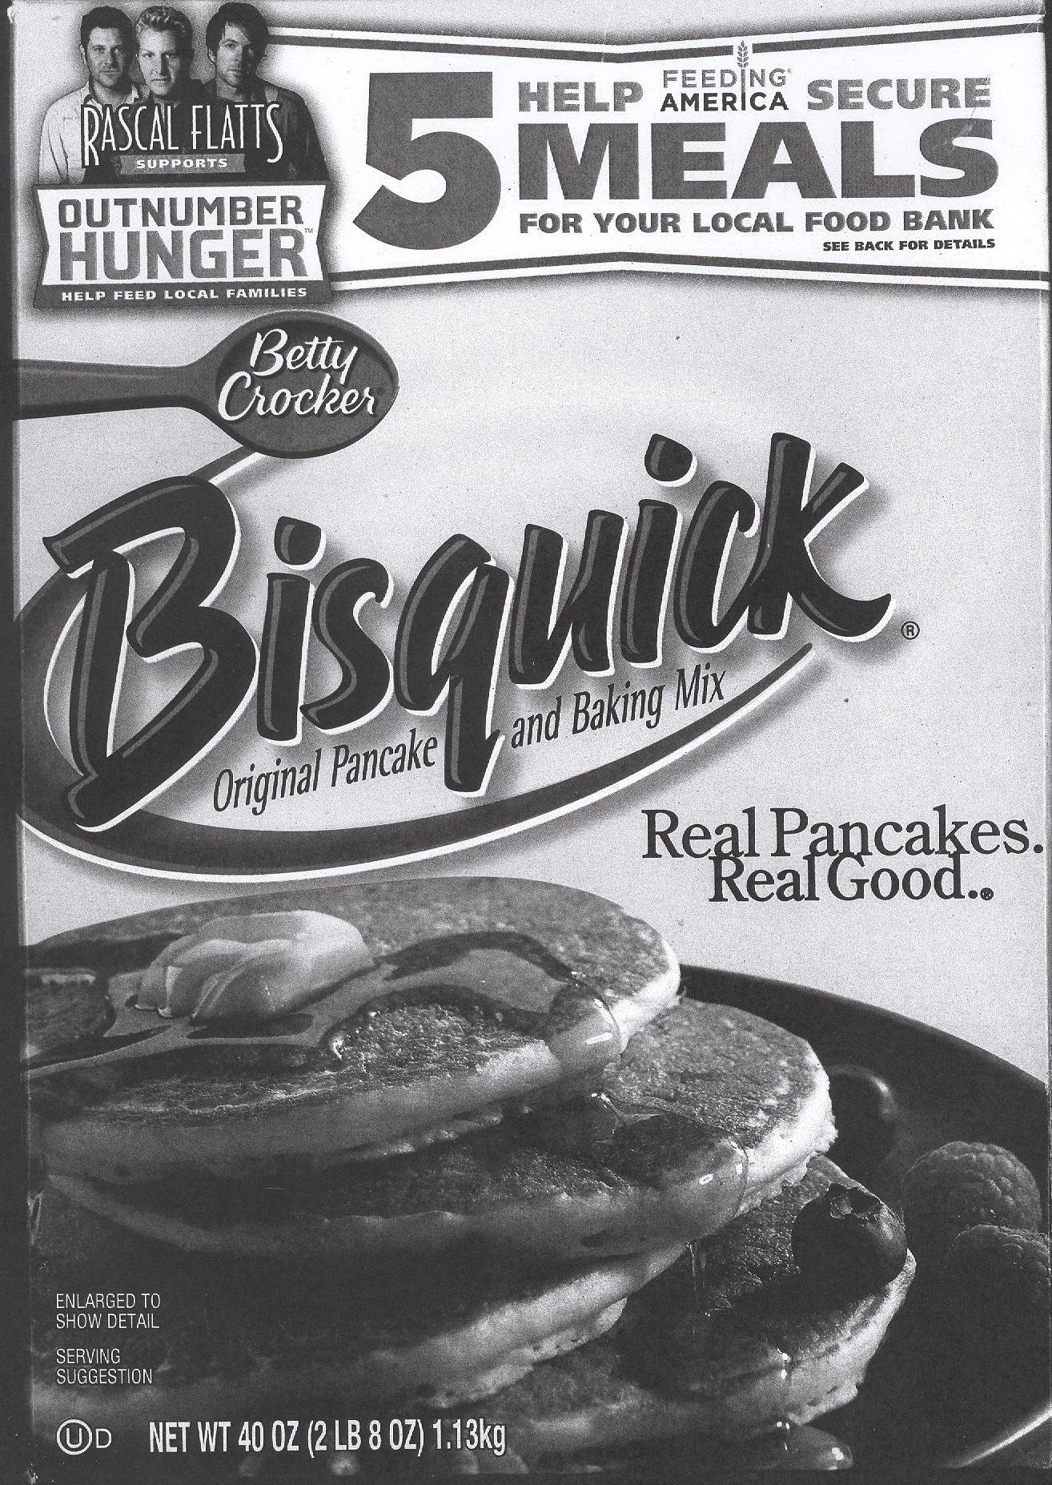

America’s Choice Pancake Syrup

Ingredients: Corn Syrup, High Fructose Corn Syrup. Water, Contains less than 2% of: Natural and Artificial Flavors, Cellulose Gum, Salt, Caramel Color, Sodium Benzoate and Sorbic Acid (Preservatives), Sodium Hexametaphosphate
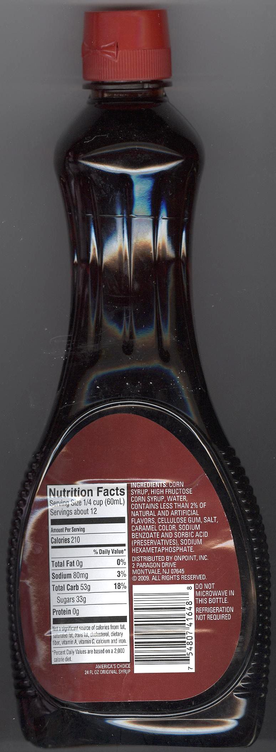
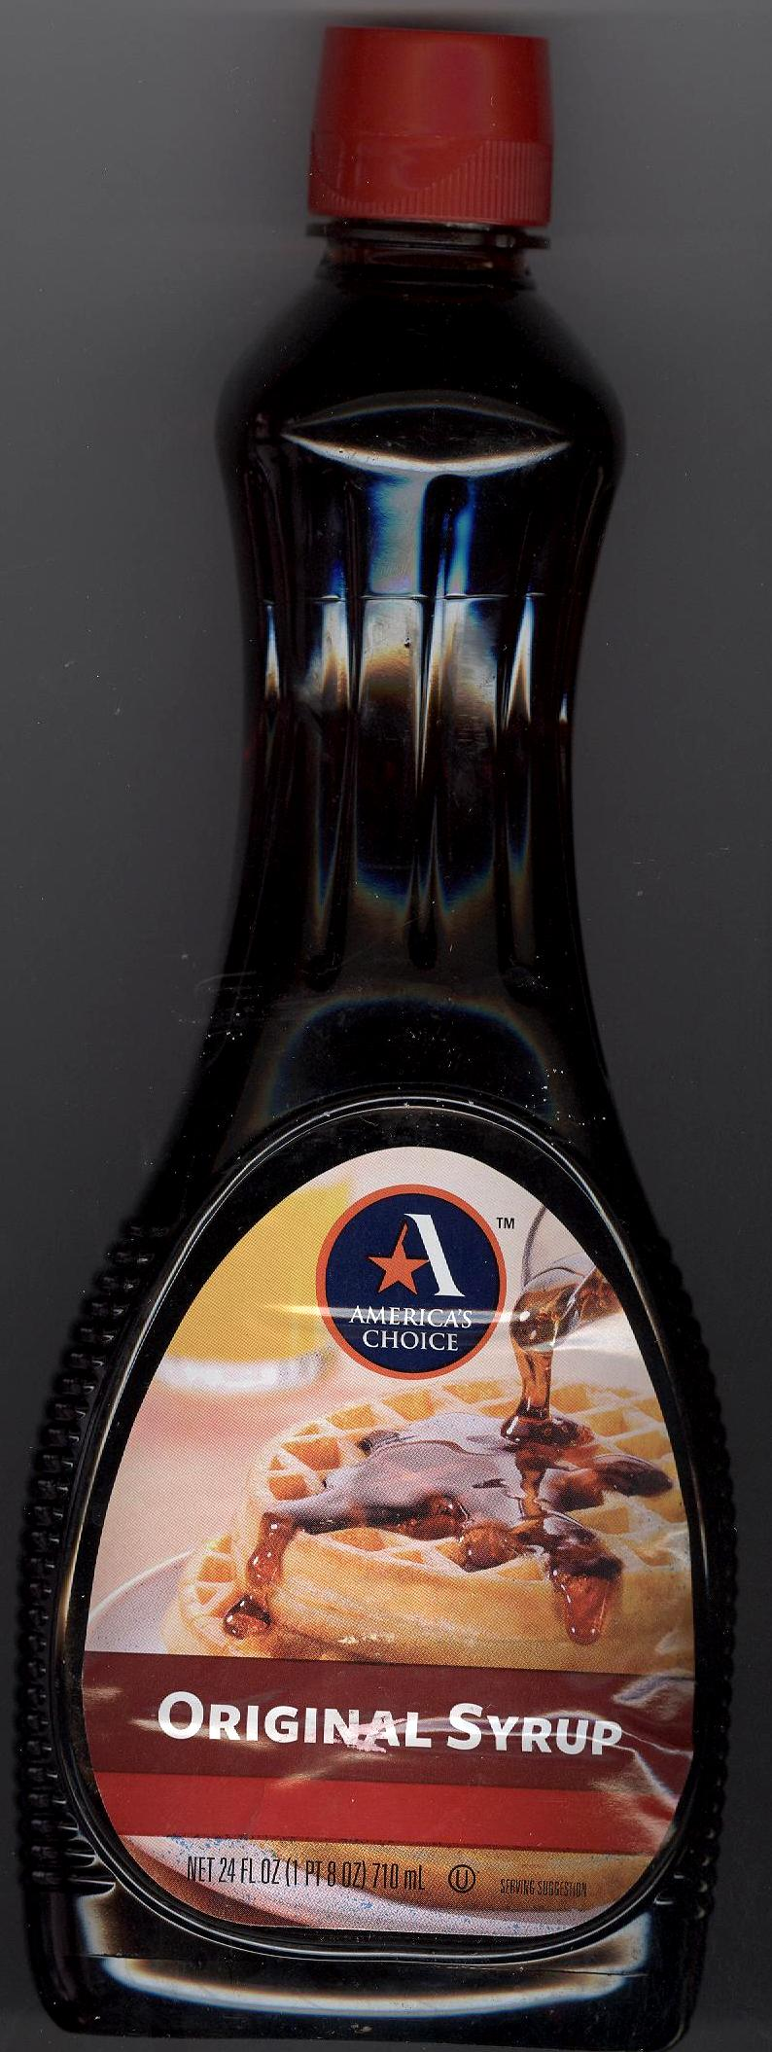

Pillsbury Refrigerator Biscuits

Ingredients: Enriched Flour Bleached (WheatFlour, Niacin, Ferrous Sulfate, Thiamin Mononitrate, Riboflavin, Folic Acid), Water, Dextrose, Baking Powder (baking soda, sodium acid pyrophosphate, sodium aluminum phosphate), Contains 2% or less of: Partially Hydrogenated Soybean Oil, Salt, Potassium chloride, Natural and Artificial Flavor, Butter

**Contains Wheat and Milk Ingredients

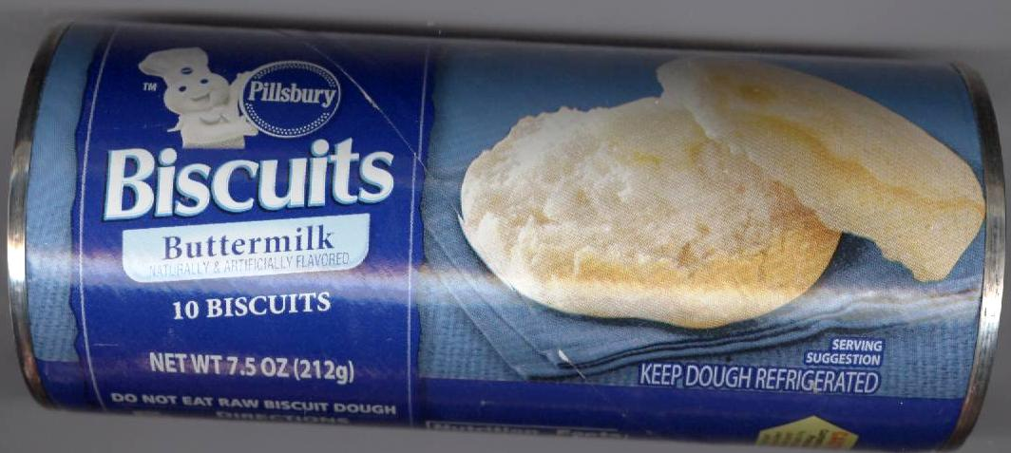

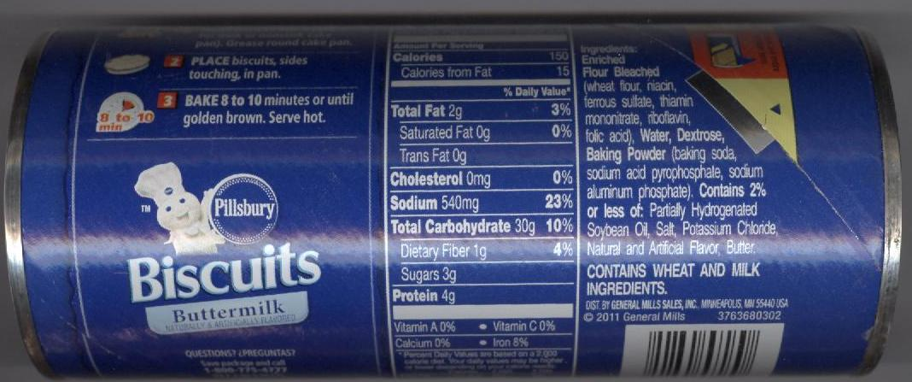

Aunt Jemima Pancake Syrup

Ingredients: Corn Syrup, High Fructose Corn Syrup, Water, Cellulose Gum, Caramel Color, Salt, Natural and Artificial Behavior, Sodium Benzoate and Sorbic Acid (Preservatives), Sodium Hexametaphosphate (595-38)

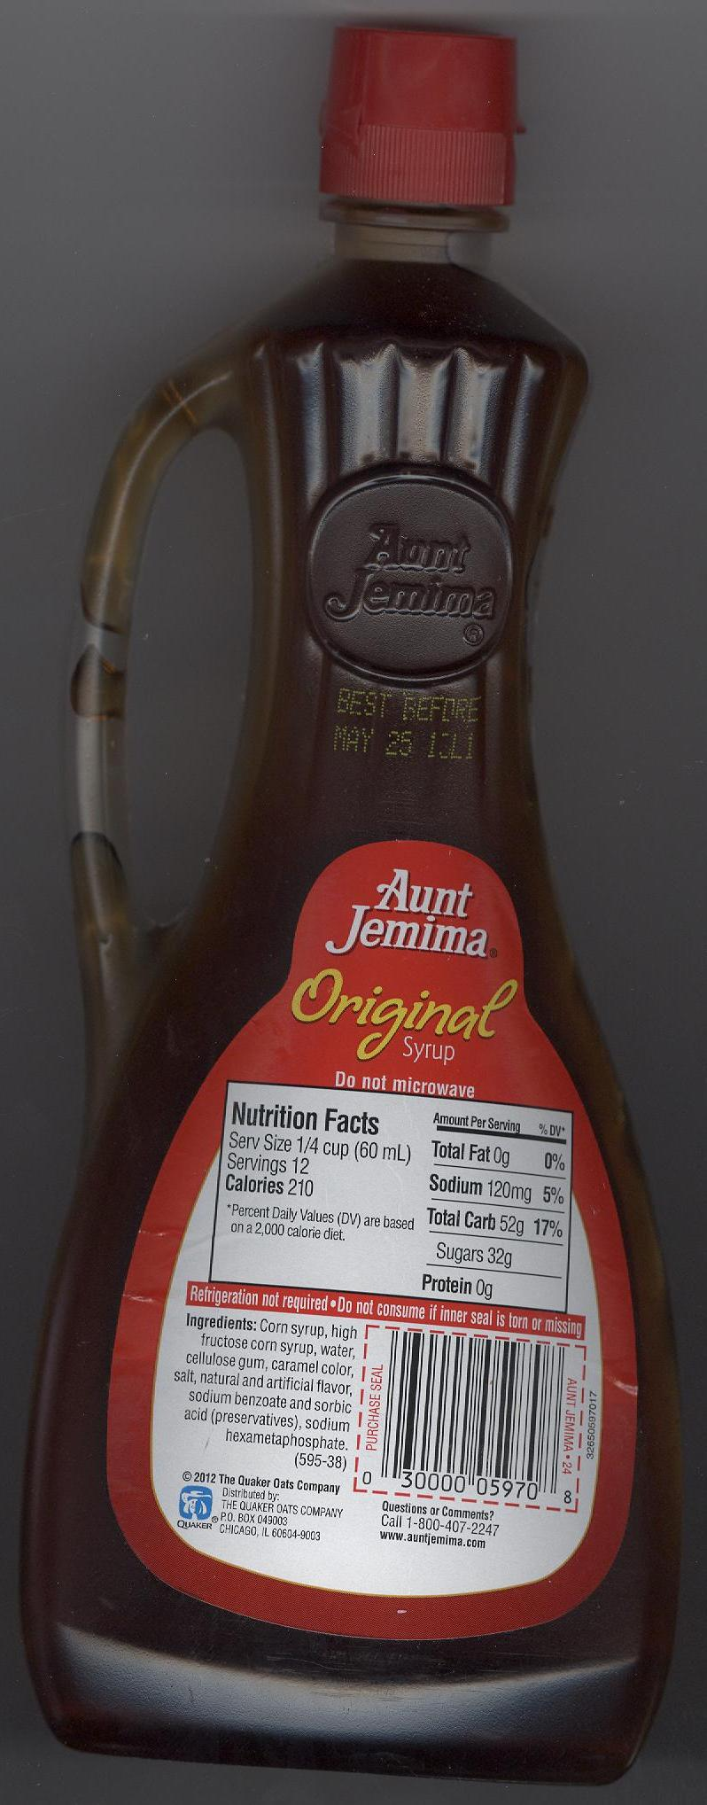
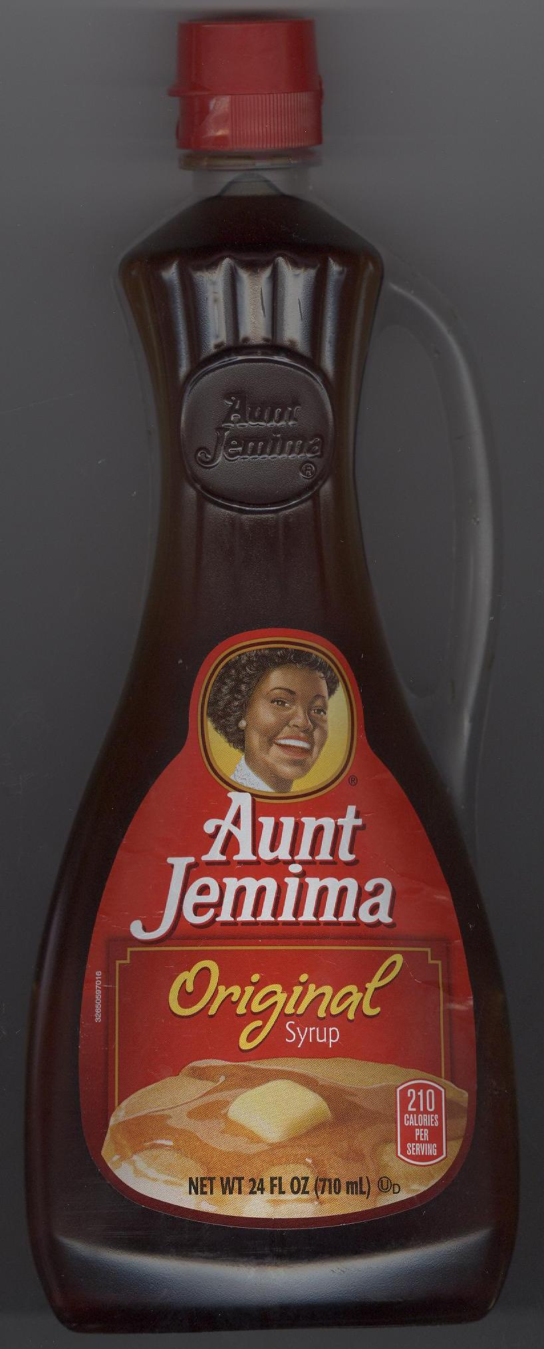

America’s Choice Unsalted Butter

Ingredients: Cream, Natural Flavorings

*Contains Milk

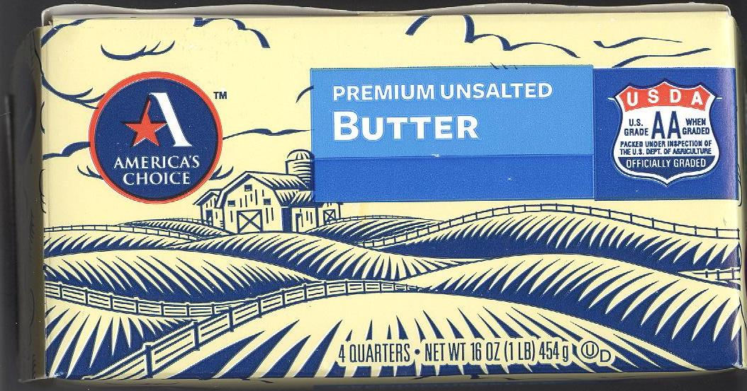

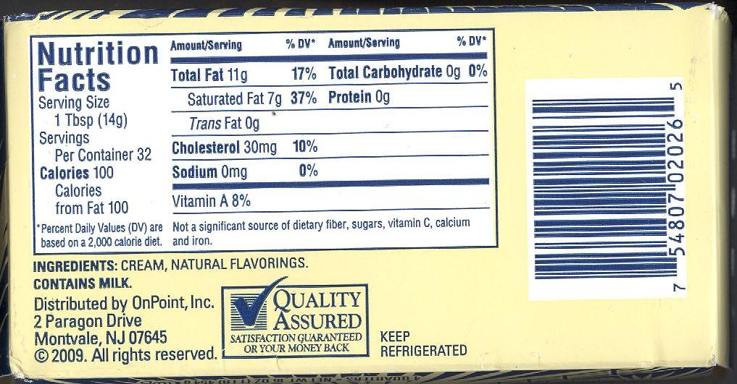

McCormick Apple Pie Spice

Ingredients: Cinnamon, Allspice, Nutmeg

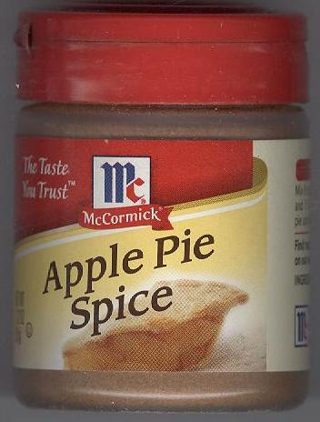

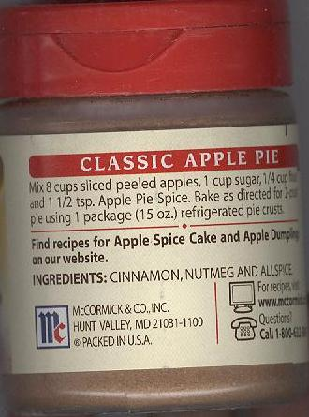

Thomas’s Whole Wheat English Muffins

Ingredients: Whole Wheat Flour (Water, Farina, Wheat Gluten, Yeast, Sugar, Salt, Preservatives- Calcium Propionate, Sorbic Acid), Grain Vinegar, Natural Flavor, Sodium Steardyl Lactylate, Mono and Diglycerides, Ethoxylated Mono-and Diglycerides), Sucralose, Soy Flour, Nonfat Milk, Whey

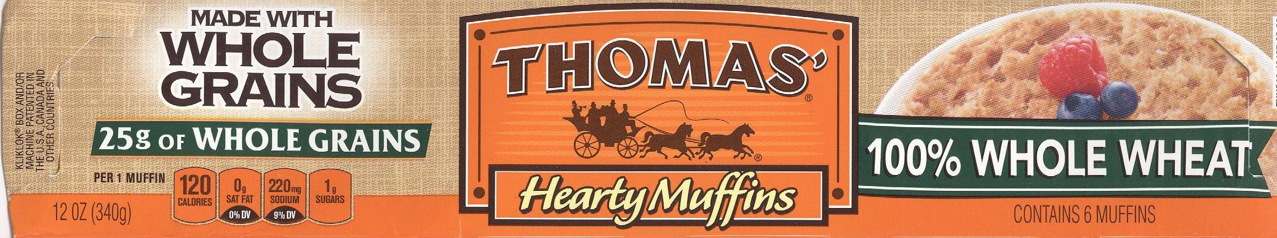

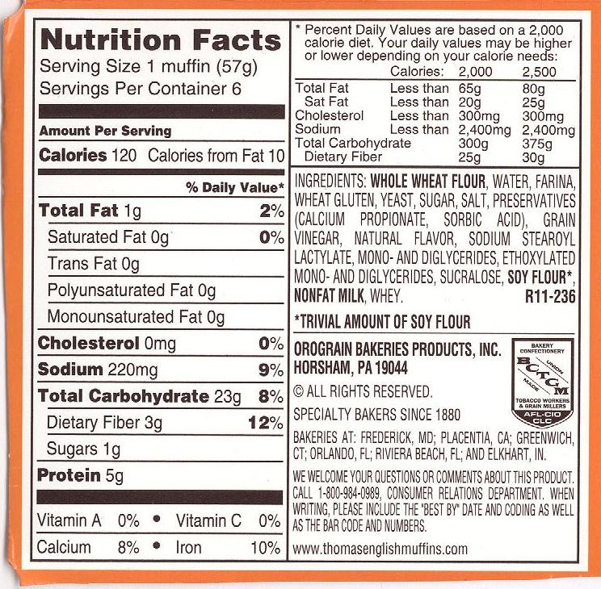
Ragu Pizza Quick Snack Sauce

Ingredients: Tomato Puree (Water, Tomato Paste), Soybean Oil, Salt, Modified Food Starch, Dried Onions, Spices, Sugar, Natural Flavor
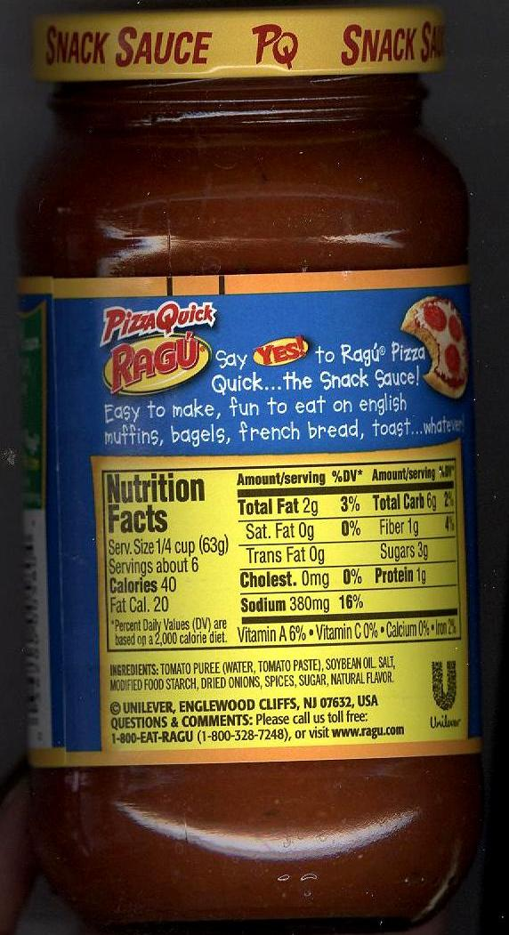
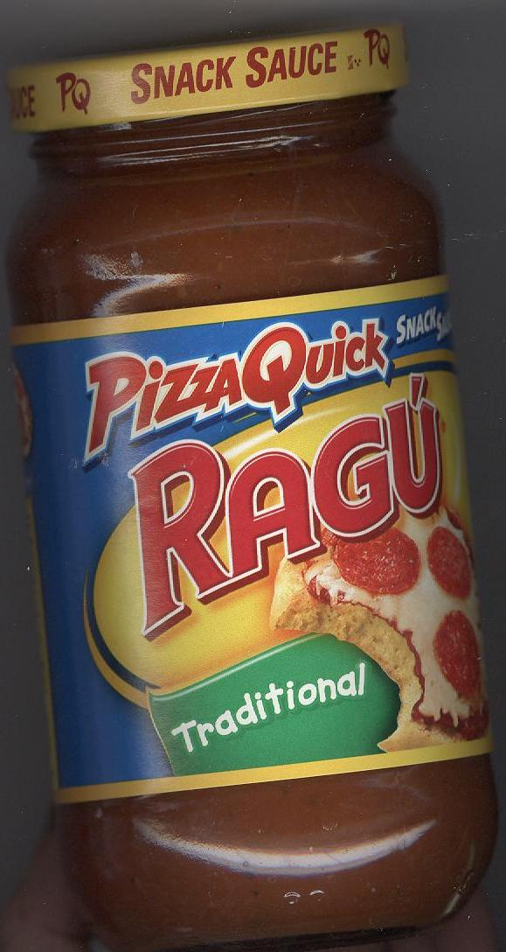

Sargento Whole Milk Mozzarella Cheese

Ingredients: Pasteurized Milk, Vinegar, Salt, Enzymes

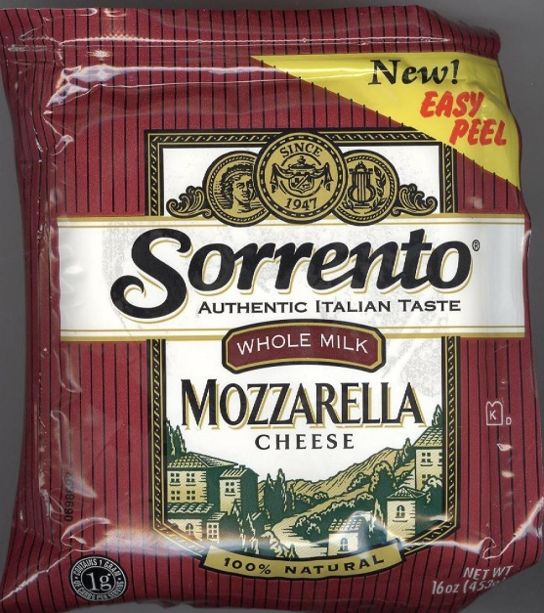

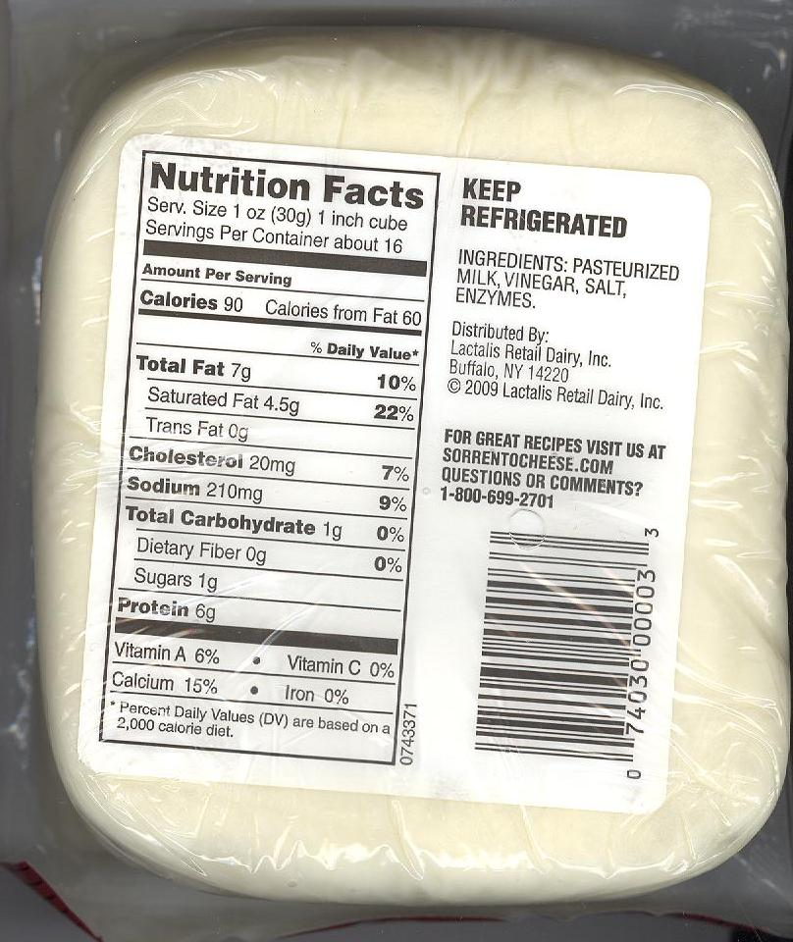

America’s Choice Parmesan Cheese

Ingredients: Parmesan Cheese (Pasteurized Cultured Milk, Salt, Enzymes, Powdered Cellulose, and Corn Starch added to prevent caking), Potassium Sorbate (Added to Protect Flavor)

*Contains Milk

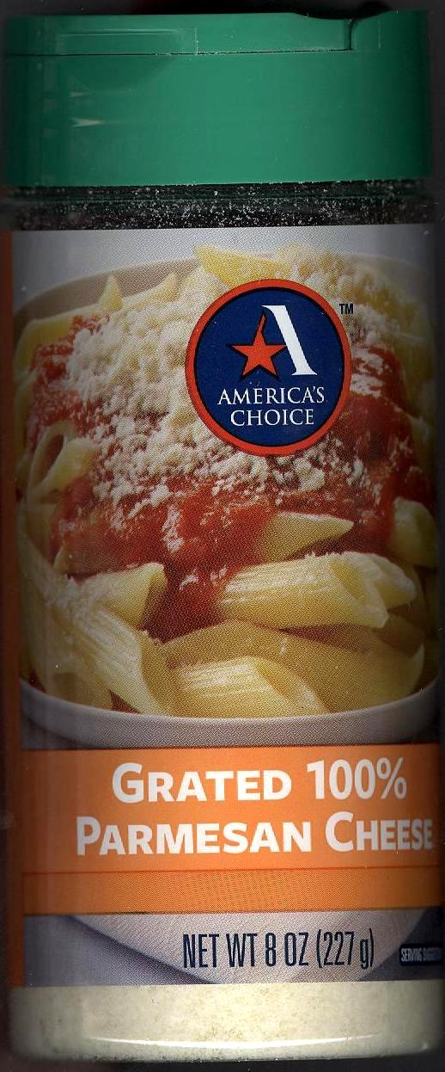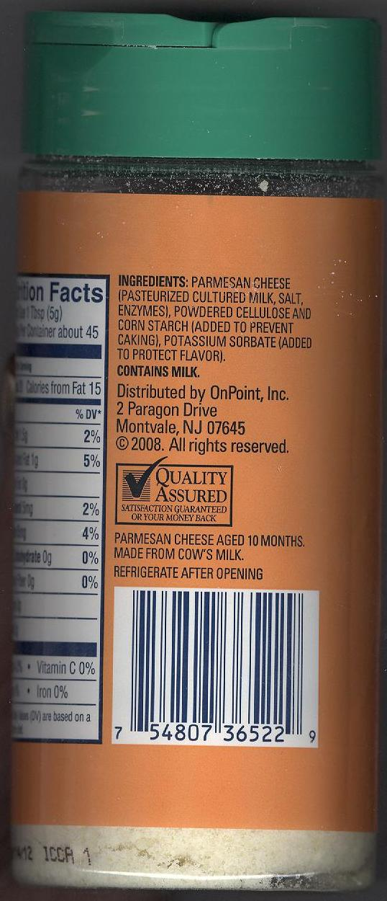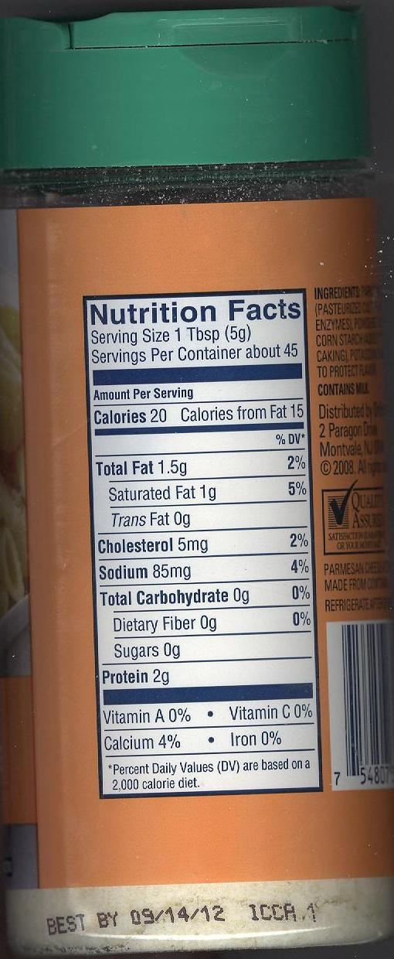

America’s Choice Chocolate Chips

Ingredients: Sugar, Chocolate Liquor, Cocoa Butter, Butterfat (Milk), Soy Lecithin, Vanilla

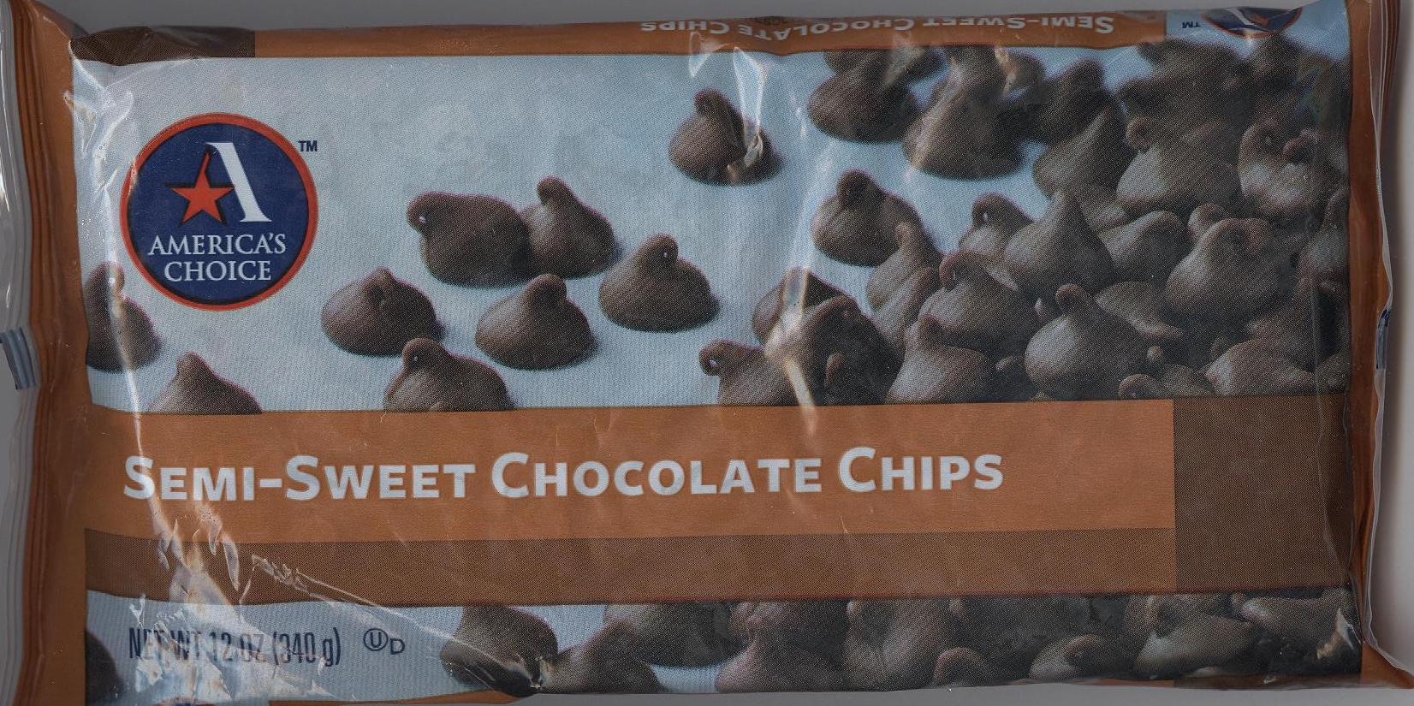

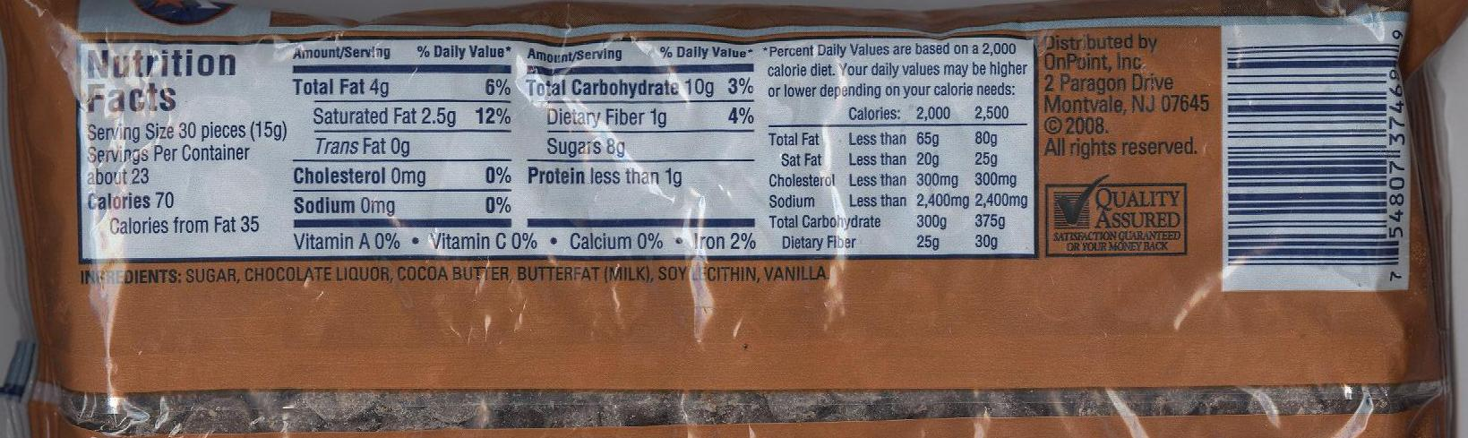

Domino Dark Brown Sugar

Ingredients: Brown Sugar

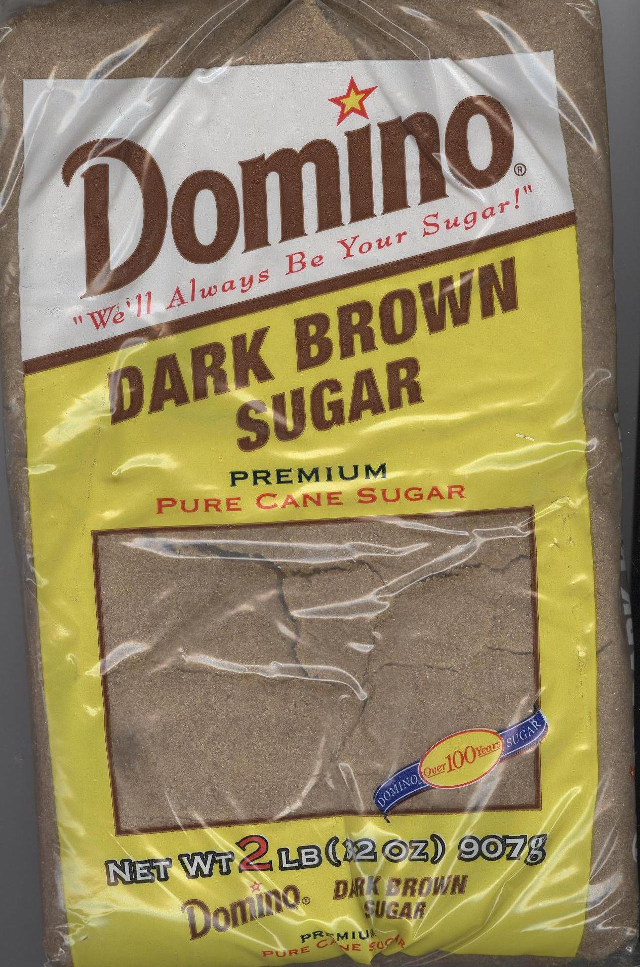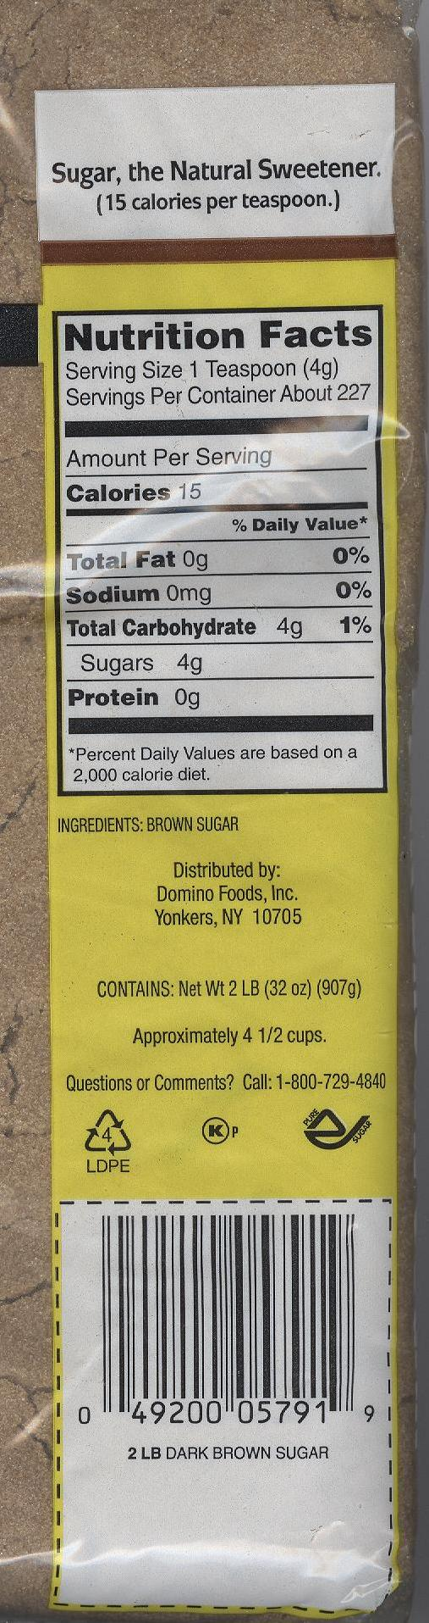
America’s Choice Imitation Vanilla Extract

Ingredients: Water, Alcohol (1%), Caramel Color, Natural and Artificial Flavors, Ethyl Vanillin, Citric Acid

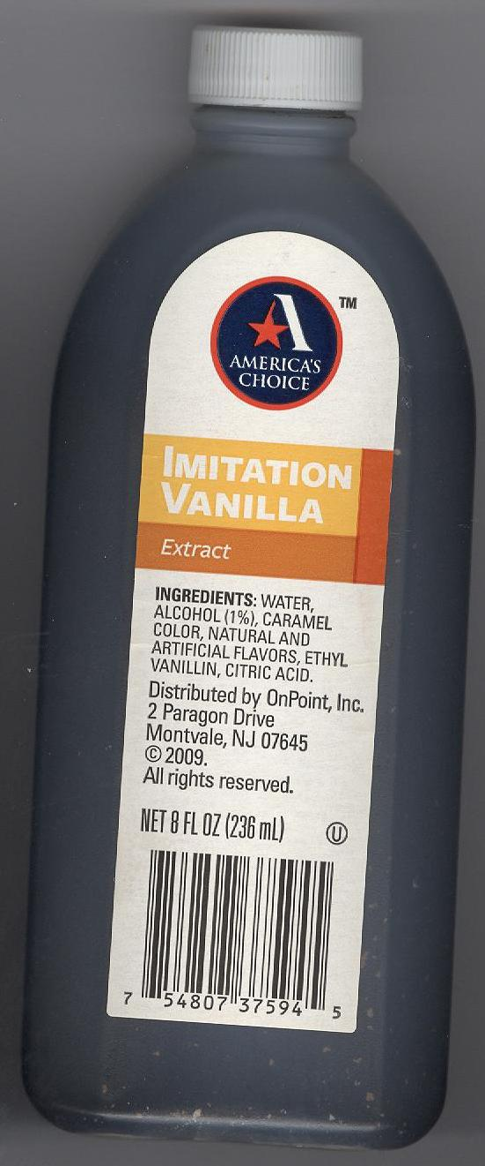

Master Choice Vanilla Extract

Ingredients: Water, Alcohol (1%), Caramel Color, Natural and Artificial Flavors, Ethyl Vanillin, and Citric Acid

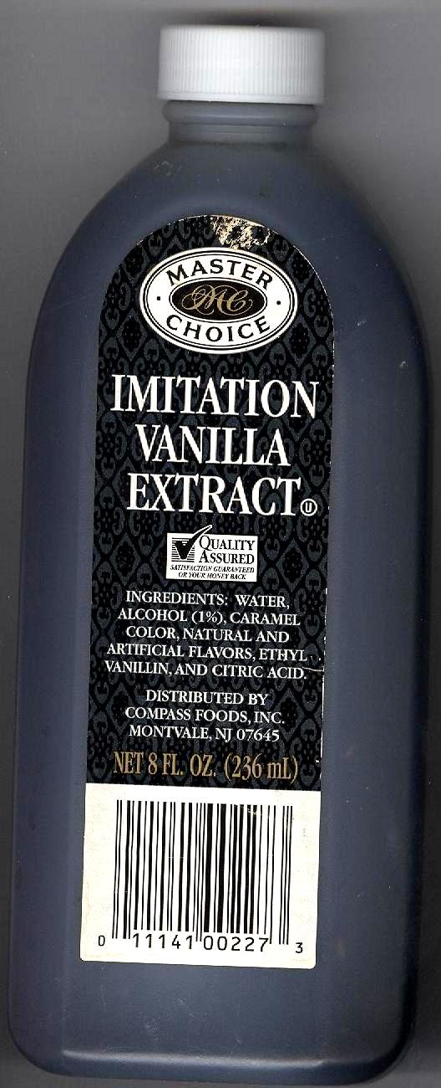

America’s Choice Canola Oil
Cooking Spray

Ingredients: Canola Oil, Soy Lecithin, Water, Propellant
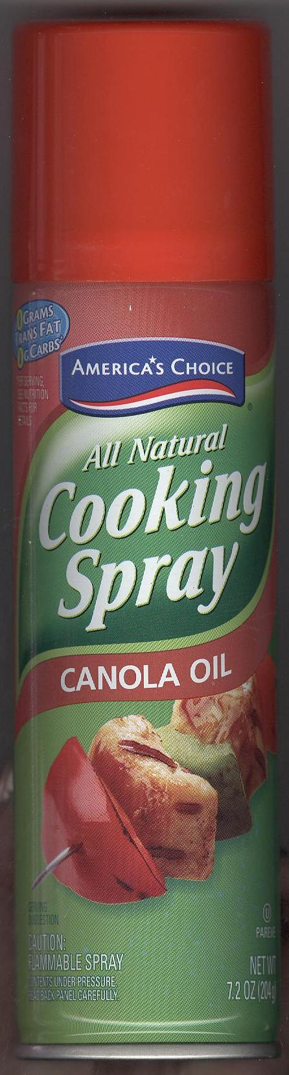
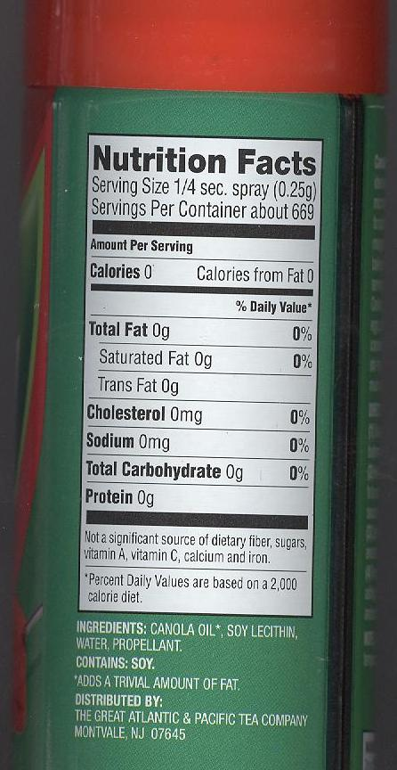
*Contains Soy

America’s Choice Vegetable Oil
Cooking Spray

Ingredients: Soybean Oil, Soy Lecithin, Water, Propellant

*Contains Soy

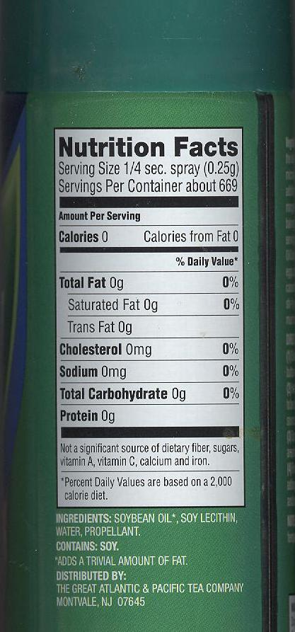

Baker’s Joy Cooking Spray

Ingredients: Soybean Oil, Propellant (Isobutane and/or Propane), Hydroxylated Soy Lecithin, Soy Lecithin, Enriched Flour (Wheat Flour, Niacin, Iron, Thiamin Mononitrate, Riboflavin, Folic Acid), Silicon Dioxide, TBHQ (To protect freshness)

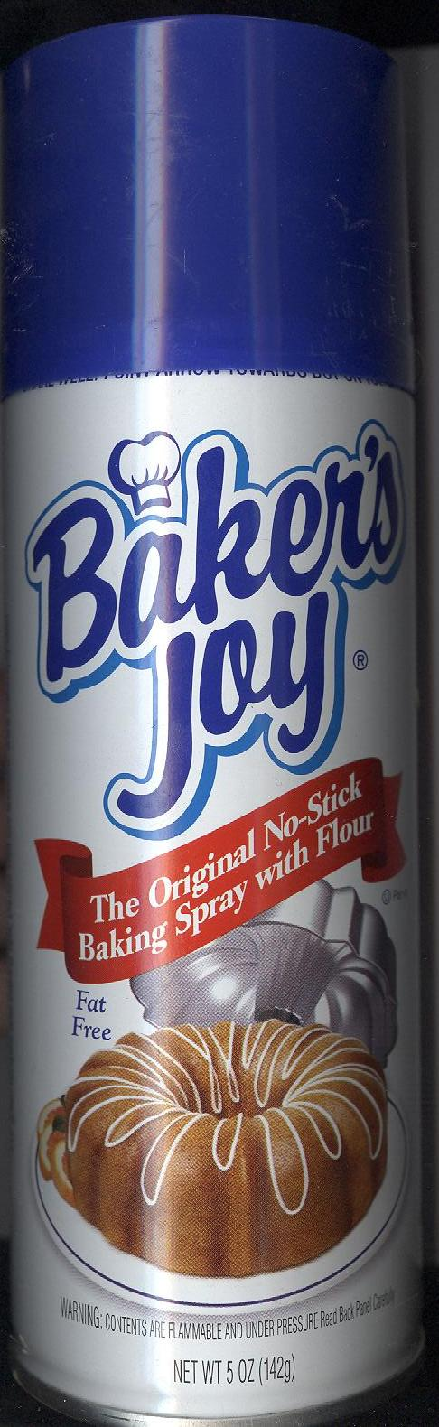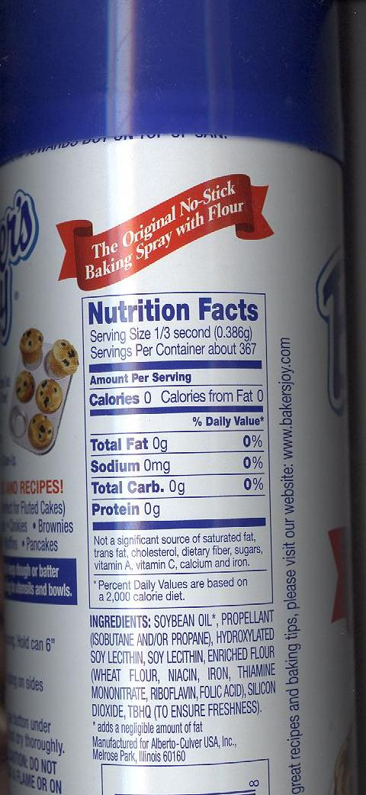

Gluten Free Bisquick

Ingredients: Rice Flour, Sugar, Leavening (Baking Soda, Sodium Aluminum Phosphate, Monocalcium Phosphate), Modified Potato Starch, Salt, Xanthan Gum

*May contain soy

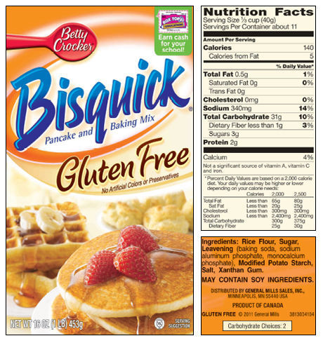

America’s Choice All-Purpose Flour

Ingredients: Enriched bleached flour (niacin, reduced iron, thiamin mononitrate, riboflavin, folic acid), malted barley flour.

** Contains Wheat

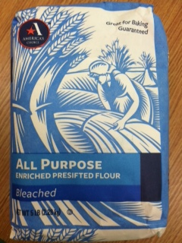

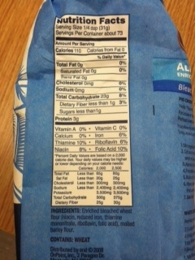

America’s Choice Fat-Free, Sugar Free
Chocolate Pudding

Ingredients: Starch Blend (Modified Tapioca Starch, Maltodextrin), Cocoa Powder Processed with Alkali, Maltodextrin, Tetrasodium Pyrophosphate, Colored Maltodextrin (with Red 40, Yellow 5, Blue 1), Disodium Phosphate, Emulsifier (Mono and Diglycerides, Nonfat Dry Milk, Modified Tapioca Startch), Contains 2% or less of Salt, Mucorcrystalline Cellulose, Titanium Dixoide (for color), Xanthan Gum, Aspartame* (Sweetener), Acesulfame Potassium (Sweetener), Natural and Artificial Flavor

Contains: Milk

* Phenylketnurics: Contains Phenylalanine

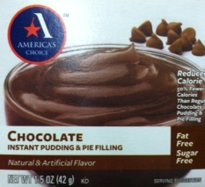

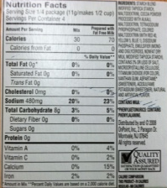
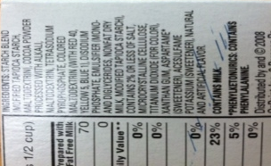

America’s Choice Fat-Free, Sugar Free
Vanilla Pudding

Ingredients: Starch Blend (Modified Tapioca Starch, Maltodextrin), Tetrasodium Pyrophosphate, Disodium Phosphate, Contains 2% or Less of Salt, Microcrystalline Cellulose, Titanium Dioxide (for color), Emulsifier (Mono and Diglycerides, Nonfat Milk, Modfied Tapioca Starch), Xanthan Gum, Aspartame* (Sweetener), Acesulfame Potassium (Sweetener), Artificial Flavors, Yellow 5, Yellow 6

Contains: Milk

* Phenylketoneurics: Contains Phenylalanine

